TABLE OF CONTENTS

437-007-0700 General Work Practices H-1
437-007-0705 General Machine Operator Requirements H-1
437-007-0710 General Machine Requirements H-3
437-007-0715 Attaching and Spooling Line (wire or synthetic rope) H-4
437-007-0720 Fairleads H-6
437-007-0725 Securing Machines H-6
437-007-0730 Loading Machines H-7
437-007-0735 Chippers H-7
437-007-0740 Machine Exhaust Systems H-7
437-007-0745 Windows and Windshields on Machines H-8
437-007-0750 Drum Brakes H-8
437-007-0755 Machine Travel Brakes H-8
437-007-0760 Outriggers H-9
437-007-0765 Hauling or Moving Machines H-9
437-007-0770 Protective Structures for Operators, General Requirements H-10
437-007-0775 Protective Structures for Operators, Machines Manufactured
On Or After July 1, 2004 H-13

437-007-0780 Protective Structures for Operators, Machines Used On
Or After July 1, 2014 H-17

437-007-0700 General Work Practices.

- Machines must be operated a sufficient distance from personnel and other machines to not create a hazard for any person.
- An unimpaired horizontal clearance of not less than 3 feet must be maintained between the rotating superstructure of any machine and any adjacent object or surface. If this clearance cannot be maintained, personnel must be warned of the pinch point area. Measures taken to warn personnel of the pinch point area may consist of a warning line constructed of rope or ribbon supported on stanchions, barriers, cones, flags, etc.
- Items of personal property, tools or other miscellaneous materials must not be stored on or within 3 feet of any machine if such items would expose personnel to hazards caused by the rotation of the machine’s superstructure.
EXCEPTION: These items may be stored within 3 feet when in a locked box or otherwise secured and under the exclusive control of the equipment operator.
- Personnel must not approach to within 3 feet of a machine when a hazardous area is created by the rotation of the machine’s superstructure without:
  - Informing the operator of their intent.
  - Receiving acknowledgment from the operator that the operator understands their intention.
  - Stopping the machine while personnel are in the hazardous area.
- No person, other than the operator, may ride on a machine unless seating, seat belts and other protection equivalent to that provided for the operator are provided.
- Operators must not permit workers to ride on arches, reaches or turns of logs.
Stat. Auth.: ORS 654.025(2) and 656.726(4).
Stats. Implemented: ORS 654.001 through 654.295.
Hist: OR-OSHA Admin. Order 5-2003, f. 6/02/03, ef. 12/01/03.

437-007-0705 General Machine Operator Requirements.

- Machines must be started and operated only by authorized personnel.
- Operators must be instructed about and comply with the manufacturer's recommen- dations for machine operation, maintenance, safe work practices, and site operating procedures.
- Before starting or moving any machine, the operator must determine that personnel are in the clear.
- Operators must inspect their machines each day before starting work.
- All machine engines must be off during inspection or repair except where necessary for adjustment or checking fluids.
- Machines must not be operated with defective steering, braking, other parts or components that are necessary for safe operation.
- Defective hydraulic hoses, lines and fittings that affect the safe operation of the machine must be immediately replaced.
- All repairs and adjustments necessary for safe operation must be made before any strain or load is placed upon any machine.
- Machines must not be operated until all guards are reinstalled, safety devices reactivated, and maintenance equipment removed after adjustments or repairs are made.
- Operators must start and operate machines only from the operator's station or from a safe area recommended by the manufacturer.
- At the start of each shift, machine operators must test all drum brakes before taking a load.
- Machines must be operated within their stability limits.
- Loads on forklift-type log handling machines must be transported:
  - As low as safely possible.
  - In a manner that minimizes obstructing the operator’s view.
- The machine operator must apply the parking brake, brake locks or other equivalent means to hold the machine stationary before dismounting.
- Blades must be lowered to the ground or other stable surfaces while the operator is out of the normal operating work station.
- Grapples, delimber masts, feller buncher attachments, forks and other similar devices must be stable and pose no hazard to others while the operator is out of the normal operating work station.
- If a hydraulic or pneumatic storage device can move machine elements, such as, but not limited to, blades, buckets, saws and shears, after the machine is shut down, the pressure or stored energy from the element must be discharged as specified by the manufacturer.
Stat. Auth.: ORS 654.025(2) and 656.726(4).
Stats. Implemented: ORS 654.001 through 654.295.
Hist: OR-OSHA Admin. Order 5-2003, f. 6/02/03, ef. 12/01/03.
437-007-0710 General Machine Requirements.

- Machine seats must be securely attached.
- Operating foot controls must be constructed of or covered with a non-slip material suitable for the footwear worn.
- Machine decks, drums and other surfaces where workers walk or stand must be constructed of or covered with a non-slip material suitable for the footwear worn.
- Catwalks or platforms must be provided on machines where personnel perform routine operation, maintenance or rigging work.
- A safe and adequate means of access and egress such as, steps, ladders, handholds and railings must be provided and maintained to all parts of vehicles and machines where employees must go. Machine access must comply with the Society of Automotive Engineers' (SAE)-J185-1988 or ISO 2867:1994, Access Systems for Off-Road Machines.
NOTE: See the mandatory requirements in Appendix 7-D for accessing metal towers.
- Guards must be provided on machines to protect employees from flying chunks, logs, chips, bark, limbs and other material.
- Guards must be in place at all times when machines are in use.
- All exposed moving parts, such as shafts, pulleys, belts, conveyers and gears on machinery and equipment must be guarded in accordance with OAR 437, Division 2, Subdivision O, Machinery and Machine Guarding.
- Hydraulic hose, tubing or fittings must be arranged to eliminate abrasive contacts.
- Machines must be free of excess flammable and combustible material that may create a fire.
- Machine sleds, bases or frames must be strong enough to withstand any imposed stresses.
- Machines and their components must be securely anchored or otherwise stabilized to prevent unintended movement during operation.
EXCEPTION: This does not apply to tractors or skidders.
- A limit switch must be installed on electric-powered log loaders to limit lift arms travel in the event the control switch is not released in time.
- When forklift type machines are used to load, unload or handle trailers, a positive means of holding the lifting attachment on the fork must be installed and used.
- Guyline drum controls and outrigger controls must be separated and clearly identified to prevent engaging the wrong control.
- Boom-type machines must have a boom stop to prevent over-topping of the boom.
Stat. Auth.: ORS 654.025(2) and 656.726(4).
Stats. Implemented: ORS 654.001 through 654.295.
Hist: OR-OSHA Admin. Order 5-2003, f. 6/02/03, ef. 12/01/03.

437-007-0715 Attaching and Spooling Line (wire or synthetic rope).

- Ends of lines attached to drums on machines must be secured by end attachments that develop the ultimate strength of the line unless three wraps of line are maintained on the drum at all times.
NOTE: This does not apply to tractors or skidders.
- Winch lines on tractors or skidders must be attached to the drums with a breakaway device.
- Wire rope must be wound on drum spools in a manner to prevent excessive wear, kinking, chafing, or fouling.
- 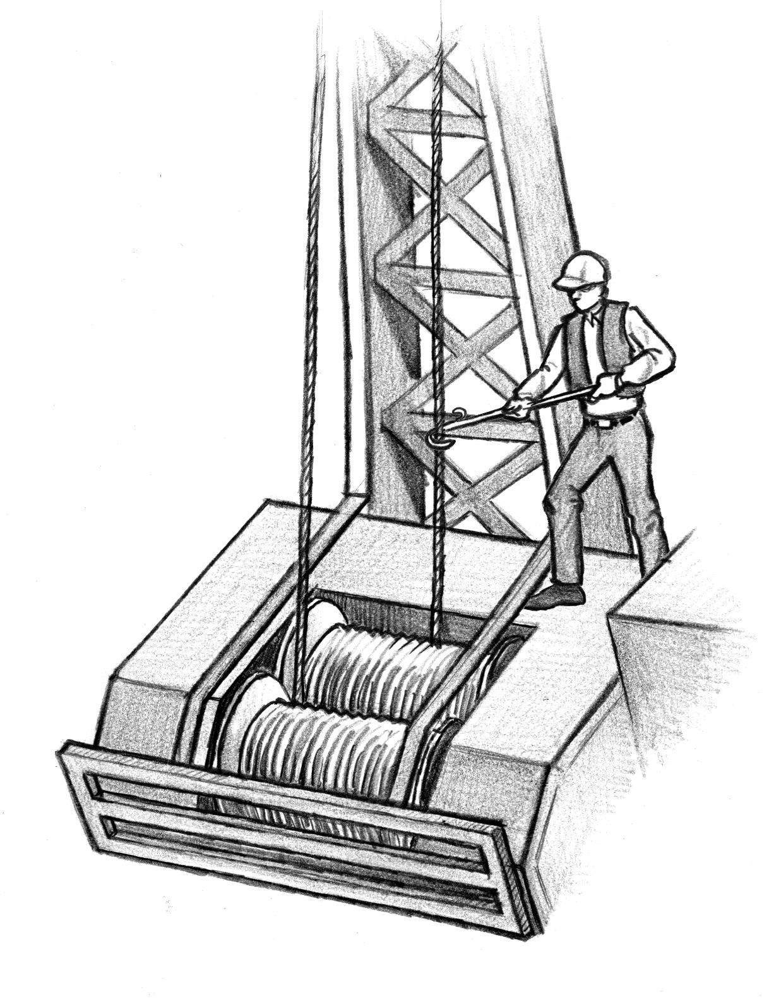A guide pulley, tool, stick, iron bar, or other manual or mechanical means must be used when guiding lines onto drums.
Figure 7-31 – Spooling Lines – Least Risky
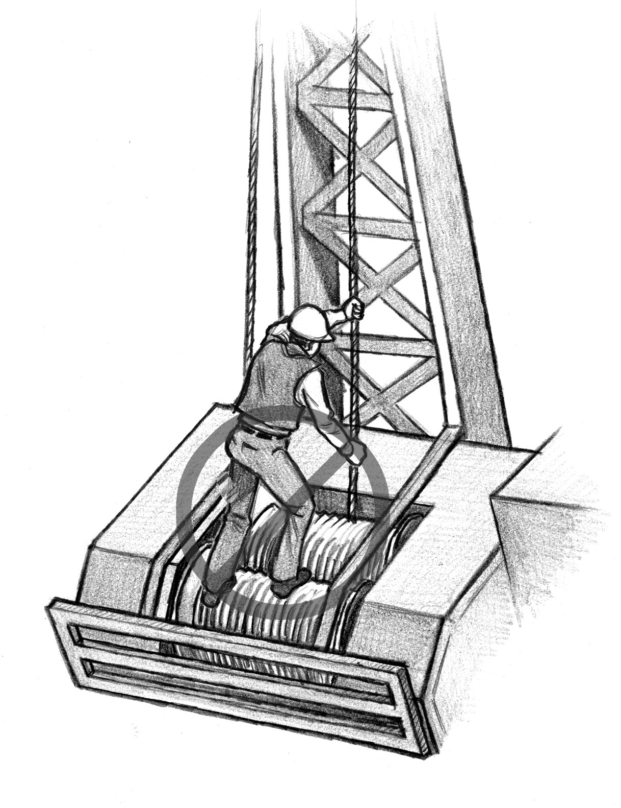
- Personnel must never allow line to slide through their gloved hands or place any part of their body in direct contact with the line.
Figure 7-32 – Spooling Lines – Risky

- When it is necessary for personnel to stand on a drum to spool line or perform machine maintenance, precautions must be taken to prevent unintentional activation of the drum.
- Personnel must not stand on a bare drum or lines spooled on a drum when wearing caulk boots unless a non-slip material covers the standing surface.
Stat. Auth.: ORS 654.025(2) and 656.726(4).
Stats. Implemented: ORS 654.001 through 654.295.
Hist: OR-OSHA Admin. Order 5-2003, f. 6/02/03, ef. 12/01/03.
437-007-0720 Fairleads.

- Properly align fairleads at all times.
- Fairleads must be of a design that will prevent line damage.
Stat. Auth.: ORS 654.025(2) and 656.726(4).
Stats. Implemented: ORS 654.001 through 654.295.
Hist: OR-OSHA Admin. Order 5-2003, f. 6/02/03, ef. 12/01/03.

437-007-0725 Securing Machines.

- Before the operator leaves the operator’s work station, procedures must be imple- mented to prevent the release of stored energy, accidental start up, or movement of the machine.
- The employer must instruct all authorized employees how to use shut down procedures.
- Authorized employees must demonstrate a working knowledge of the specific shut down procedures they are required to use.
- Locks, tags and other devices used to control hazardous energy must be durable.
- The words “DO NOT START,” “DO NOT OPERATE,” or other appropriate warning must be displayed on tags used to control energy.
- Tags used to control hazardous energy must be placed so they are obvious to anyone attempting to operate the machinery.
- Blades must be lowered to the ground or other stable surfaces to secure the blade and machine from movement while maintenance or repair activities are performed.
- Grapples, delimber masts, feller buncher attachments, forks and other similar devices must be stable and not pose a hazard to personnel while maintenance or repair activities are performed.
- If a hydraulic or pneumatic storage device can move machine elements, such as blades, buckets, saws, shears, etc., after the machine is shut down for maintenance or repair, the pressure or stored energy that can activate the movable elements must be discharged.
- Before locks, tags and other devices that are used to control hazardous energy are removed and machinery or equipment is started, the work area must be inspected to ensure that:
  - All tools have been removed.
  - Personnel are in the clear.
- Guards must be replaced after necessary adjustments are made.
- Machines or equipment that are not mounted on sleds, wheels, or tracks must comply with the requirements of Division 2/J, §1910.147, for controlling hazardous energy.
Stat. Auth.: ORS 654.025(2) and 656.726(4).
Stats. Implemented: ORS 654.001 through 654.295.
Hist: OR-OSHA Admin. Order 5-2003, f. 6/02/03, ef. 12/01/03.

437-007-0730 Loading Machines.

- Grapple arms or other positive means of keeping logs on the forks must be used on forklift type log handling and loading machines.
- Log loading machines must be equipped with an audible signaling device of a different tone than other signaling devices in the area.
Stat. Auth.: ORS 654.025(2) and 656.726(4).
Stats. Implemented: ORS 654.001 through 654.295.
Hist: OR-OSHA Admin. Order 5-2003, f. 6/02/03, ef. 12/01/03.

437-007-0735 Chippers.

- Access covers and doors to chippers must remain closed until the drum or disk is at a complete stop.
- Infeed and discharge ports on chippers must prevent contact with discs, knives, or blower blades.
Stat. Auth.: ORS 654.025(2) and 656.726(4).
Stats. Implemented: ORS 654.001 through 654.295.
Hist: OR-OSHA Admin. Order 5-2003, f. 6/02/03, ef. 12/01/03.

437-007-0740 Machine Exhaust Systems.

- Machines must have an exhaust system maintained in good working order.
- Machines must be equipped with a muffler of the type recommended by the machine manufacturer.
- Exhaust pipes must direct the exhaust gases away from the operator.
- Exhaust pipes must be insulated or located to protect employees from accidental contact with the pipes and must permit spark arrester clean out.
Stat. Auth.: ORS 654.025(2) and 656.726(4).
Stats. Implemented: ORS 654.001 through 654.295.
Hist: OR-OSHA Admin. Order 5-2003, f. 6/02/03, ef. 12/01/03.
437-007-0745 Windows and Windshields on Machines.

- Windows and windshields must:
  - Be free of deposits or defects that could endanger the operator or other personnel.
  - Be safety glass or a type of material that provides equal protection.
  - Not impair the vision of the operator.
  - Have an additional metal screen or guard where windows and windshields do not provide adequate operator protection.
Stat. Auth.: ORS 654.025(2) and 656.726(4).
Stats. Implemented: ORS 654.001 through 654.295.
Hist: OR-OSHA Admin. Order 5-2003, f. 6/02/03, ef. 12/01/03.

437-007-0750 Drum Brakes.

- Brakes or dogs must be installed on all machine drums and maintained in effective working condition.
- Machine drum brakes must have an independent locking device that will hold the drum when the operator leaves the machine and the machine is not operating.
- Machine drum brakes must be protected from direct exposure to the elements or must be of a design or construction which will render them impervious to such exposure.
Stat. Auth.: ORS 654.025(2) and 656.726(4).
Stats. Implemented: ORS 654.001 through 654.295.
Hist: OR-OSHA Admin. Order 5-2003, f. 6/02/03, ef. 12/01/03.

437-007-0755 Machine Travel Brakes.

- Self-propelled machines built on or after July 1, 1985, must have braking systems as follows:
  - A service braking system that is the primary means of stopping and holding the equipment.
  - An emergency stopping system that is a secondary means of stopping the equipment in the event of any single failure of the service system.
  - A parking brake system that will continuously hold a stopped machine stationary within the limits of traction so the operator may leave the vehicle without the vehicle moving, and to prevent movement of the vehicle while unattended.
- The braking systems in this section (OAR 437-007-0755) must comply with Society of Automotive Engineers' (SAE) or International Organization for Standards (ISO) Recom- mended Practices:
  - ISO 11512 MAR95 – Braking Performance – In-Service Crawler Tractors and Crawler Loaders.
  - J/ISO 3450 JAN98 – Earthmoving Machinery – Braking Systems of Rubber-Tired Machines – Systems and Performance Requirements and Test Procedures.
  - J/ISO 11169 FEB99 – Machinery for Forestry – Wheeled Special Machines – Vocabulary, Performance Test Methods, and Criteria for Brake Systems.
- Self-propelled logging machines manufactured prior to July 1, 1985, must have braking systems installed, tested and maintained in as effective a condition as originally installed by the manufacturer.
Stat. Auth.: ORS 654.025(2) and 656.726(4).
Stats. Implemented: ORS 654.001 through 654.295.
Hist: OR-OSHA Admin. Order 5-2003, f. 6/02/03, ef. 12/01/03.

437-007-0760 Outriggers.

- All outriggers must be placed on a stable base or cribbing.
- Hydraulic outriggers must have a positive holding device (velocity fuse, load check valve, manually operated valve, or equivalent) to prevent movement of the piston in the event of a hose, hose fitting or other failure in the hydraulic system.
Stat. Auth.: ORS 654.025(2) and 656.726(4).
Stats. Implemented: ORS 654.001 through 654.295.
Hist: OR-OSHA Admin. Order 5-2003, f. 6/02/03, ef. 12/01/03.

437-007-0765 Hauling or Moving Machines.

- The weight of any machine being hauled must not exceed the designed capacity of the transporting vehicle.
- Machines must be loaded, secured and unloaded so they do not create a hazard for personnel.
- Machines must not be moved or operated until all personnel are in the clear.
- A signal person must guide operators who do not have a clear and unobstructed view of the direction of travel and the surface being traveled.
- When an operator does not have a clear and unobstructed view of the direction of travel, an audible alarm or horn must be sounded before the machine, equipment or vehicle is moved.
- Track-mounted machines with manual transmissions must be equipped with a ratchet or other device which will prevent unintended disengagement or reversing of the machine, and the operator must be informed of the proper technique.
- When moving machines equipped with metal towers, the tower must be lowered. When needed for mobility, the tower may be raised provided that it is adequately supported so that the stability of the machine is not impaired during movement.
Stat. Auth.: ORS 654.025(2) and 656.726(4).
Stats. Implemented: ORS 654.001 through 654.295.
Hist: OR-OSHA Admin. Order 5-2003, f. 6/02/03, ef. 12/01/03.

437-007-0770 Protective Structures for Operators, General Requirements.

- Cabs and protective structures for machine operators must be:
  - Provided when machine use exposes an operator to hazardous conditions.
  - Sufficient in strength and dimension to withstand the impact of materials handled.
- Operator controlled skidding machines manufactured after April 1, 1992, must have adequate operator protection of 1/4-inch woven wire mesh with openings no greater than 2 inches in size or other materials providing equivalent or greater protection.
- Every tractor, skidder, front-end loader (other than high mast forklifts), scraper, grader and dozer manufactured on or after July 1, 1969, must be equipped with Roll-Over Protective Structures (ROPS) installed, tested and maintained in accordance with Division 2/N, OAR 437-002-0223, as amended through January 30, 2003.
EXCEPTION: This rule does not apply to log stackers used exclusively to lift, transport or stack logs in sorting yards or transfer stations.
- Every tractor, skidder, front-end loader (other than high mast forklifts), scraper, grader and dozer manufactured on or after July 1, 1980, must be equipped with ROPS meeting the Society of Automotive Engineers' SAE 1040 April 1980, Performance Criteria for Roll-Over Protective Structures (ROPS) for Construction, Earthmoving, Forestry and Mining Machines.
EXCEPTION: This rule does not apply to log stackers used exclusively to lift, transport or stack logs in sorting yards or transfer stations.
- Every tractor, skidder, front-end loader, scraper, grader and dozer manufactured on or after July 1, 1980, must be equipped with a falling object protective structure (FOPS) for overhead protection installed, tested and maintained in accordance with the Society of Automotive Engineers' SAE J231-1981, Minimum Performance Criteria for Falling Object Protective Structures (FOPS).
- Machines equipped with ROPS or FOPS as required in OAR 437-007-0770(3), (4) and (5) must comply with the Society of Automotive Engineers' SAE J397April-1988, Deflection Limiting Volume (DLV) for Laboratory Evaluation of Roll-Over Protective Structures (ROPS), and Falling Object Protective Structures (FOPS) for Construction and Industrial Vehicles.
- The ROPS structure must have a shear or deflecting guard extending from the leading edge of the forward arch to the front part of the tractor frame. If longitudinal arches are used, they must extend from the rear of the tractor to the front frame of the tractor with each arch having an intermediate support located approximately at the dash so that operator access or egress is not impeded.
EXCEPTION: This rule does not apply to rubber-tired loaders, scrapers and graders.
- The opening in the rear of the ROPS structure must be covered with 1/4-inch woven wire having not less than 1 1/2-inch or more than 2-inch openings, or other material providing equivalent or greater protection. Affix this covering to the structural members so that ample clearance is provided between the screen and the back of the operator.
- ROPS structures must have side screens of the same strength as the back screen or vertical barrier bars spaced at intervals not greater than 6 inches on center and constructed of not less than 1-inch double strength pipe installed on all logging machines equipped with ROPS in addition to the back screen.
- Side barriers must extend forward to the front edge of the operator's seat or as far forward as possible from the rear corners of the canopy sides to a structural member behind the front edge of the seat.
- Protective structures must be of sufficient height and width so they:
  - Do not impair the movement of the operator or prevent immediate escape from the machine in emergencies.
  - Allow the operator as much visibility as possible.
- Clearance between the deck and the protective structures of the machines at points of egress must not be less than 52 inches.
- There must be a second means of egress from all logging machines.
- Structural members of the ROPS must have smooth, rounded edges and coverings free from projections which could puncture or tear flesh or clothing.
- Rollover protective systems must be maintained in a manner that will preserve their original strength. Welding may only be performed by qualified welders.
- Certified roll-over protective structures must be identified by a metal tag:
  - Permanently attached to the ROPS in a position where it can be easily read.
  - Permanently and clearly stamped, etched or embossed with the:
    - Name and address of the certifying manufacturer or registered professional engineer.
    - ROPS model number (if any).
    - Vehicle make, model or series number that the ROPS is designed to fit.
    - Maximum weight of the machine for which the structure is certified.
    - SAE tag criteria number.
- Tractors and skidders manufactured prior to 1969 that cannot be fitted with complete ROPS may be used for cleaning debris off landings, snubbing vehicles and machines or as an anchor, provided no clearing, road construction or yarding is performed off a road or landing surface.
- Seat belts must be provided and used on all machines with ROPS/FOPS and have quick release buckles designed to minimize the possibility of accidental release.
- Seat belts must be maintained in an effective condition and comply with SAE Standard J386-1985.
Stat. Auth.: ORS 654.025(2) and 656.726(4).
Stats. Implemented: ORS 654.001 through 654.295.
Hist: OR-OSHA Admin. Order 5-2003, f. 6/02/03, ef. 12/01/03.

437-007-0775 Protective Structures For Operators, Machines Manufactured On Or After July 1, 2004.

NOTE: The scope of coverage in the SAE and ISO standards referenced in OAR 437-007-0775(11) and (14) are not intended to exclude any machines included in the scope of this Division.
- Machines manufactured on or after July 1, 2004, that permit the operator to stand on the ground adjacent to the machine while operating the machine:
  - Are not required to have a fully enclosed cab.
  - Must have overhead and landing chute side protection meeting the requirements of SAE J1084 April 80.
- Cabs and protective structures on forest activities machines manufactured on or after July 1, 2004, must have smooth, rounded edges and coverings free from projections which could puncture or tear flesh and clothing.
- Any machine operator cab, protective structure or attached guarding manufactured on or after July 1, 2004, that is damaged or weakened, to a strength less than that required by certified performance criteria must be replaced or immediately repaired.
- Repairs or modifications to major structural members of any operator cab, protective structure or attached guarding on machines manufactured on or after July 1, 2004, certified to performance criteria, must comply with the specific instructions of the original equipment manufacturer or be certified by a professional engineer.
- An operator restraint system must be provided and used on all machines manufactured on or after July 1, 2004, and equipped with ROPS, FOPS, reinforced cabs or overhead guards. The operator restraint system must:
  - Comply with SAE J386 NOV97 or ISO 6683 Amended 1:1990.
  - Be maintained in an effective condition.
EXCEPTION: Use of the operator restraint system is not required when operating yarders that are stationary.
- The level of protection provided by any machine operator cab, protective structure or attached guarding manufactured on or after July 1, 2004, must be identified by a label. The label must:
  - Comply with the labeling requirements of ISO 3471:1994 or ISO 12117:1997 as applicable.
  - Not claim that exclusion from a standard is equivalent to compliance with that standard.
NOTE: Machines capable of 360-degree upper structure rotation are excluded from the SAE J1040 MAY94 and ISO 8082:1994 standards for ROPS. In this case, the exclusion from these standards does not allow the label on a machine capable of 360-degree upper structure rotation to state compliance with SAE J1040 MAY94 or ISO 8082:1994.
- Each machine used in forest activities that is manufactured on or after July 1, 2004, must have a fully enclosed cab for the operator which prevents objects from entering the cab. The fully enclosed cab must have:
  - The upper portion enclosed with materials that allow for maximum visibility and meets the Operator Protective Structure (OPS) requirements of SAE J1084 APR80 or ISO 8084:1993.
  - Transparent material must not have defects, such as, but not limited to, scratches, cracks, or broken safety glass which could create a hazard for the operator.
  - The lower portion enclosed with solid material meeting the requirements of SAE J1084: APR80 or ISO 8084:1993.
  - The overhead covering enclosed with solid material meeting the FOPS requirements of ISO 8083:1989 (11,600 Joules).
EXCEPTION 1: 437-007-0775(7)(a) is not required for the front window in machines operating in sort yards, on landings and similar prepared surfaces which are equipped with front guards meeting the SAE J1356 FEB88 requirements.
EXCEPTION 2: 437-007-0775(7)(a) and (7)(c) are not required on machines operating in mill yards.
- The machine operator space in cabs and protective structures manufactured on or after July 1, 2004, must comply with ISO 3411:1995.
- Access to machine operator cabs and protective structures manufactured on or after July 1, 2004, must comply with SAE J185-1988 or ISO 2867:1994.
- Each fully enclosed cab installed on machines manufactured on or after July 1, 2004, must have a second means of egress which can be opened from both the inside and outside without tools.
- Machines capable of handling material in front of or above the deflection limiting volume (DLV), as defined by SAE J397 APR98, including yarders with cabs mounted next to the tower (boom), manufactured on or after July 1, 2004, must have a front and top guard meeting the requirements of SAE J1356:FEB88.
EXCEPTION: The rule does not apply to rubber-tired or tracked front-end loaders when equipped with buckets or forks with hold down grapple arm(s).
- Machines used for forest activities and those identified by SAE J1116 MAR99 that are manufactured on or after July 1, 2004, must:
  - Be equipped with ROPS which meet the criteria in SAE J1040-1994 or ISO 8082:1994.
  - Comply with the requirements of OAR 437-007-0775(2) through (11).
EXCEPTION 1: This rule does not apply to high mast log stackers used exclusively to lift, transport or stack logs in sorting yards or transfer stations.
EXCEPTION 2: This rule does not apply to machines capable of 360-degree upper structure rotation that are excluded from SAE J1040:May 94 and ISO 8082:1994 standards for ROPS.
- Shear or deflector guarding must be:
  - Installed in front of each cab to deflect whipping saplings and branches.
  - Located so they do not impede visibility and access to the cab.
EXCEPTION: This rule does not apply to rubber-tired loaders, scrapers and graders.
- Machines used for forest activities manufactured on or after July 1, 2004, that are excluded from the ROPS, SAE J1040:1994 or ISO 8082:1994 requirements because they are capable of 360 degree upper structure rotation must be equipped with fully enclosed cabs that meet the requirements of 437-007-0775(2) through (11). These machines must be limited to use on surfaces that are prepared, excavated or constructed of solid material with a slope of less than 20 percent unless the operator’s cab is equipped with the following additional protection:
  - A Tip Over Protective Structure (TOPS) that meets the requirements of ISO 12117 1997:(E) with the exception of the “Formulae for the determination of energy required” in section 6.1.4 Table 1. The “Formulae for the determination of energy required” in Table 1 is changed as follows:
    - The lateral energy equation is replaced with 7300(M/10,000)^{0.9} or 20,000 Joules, whichever is greater where M is the machine mass in kilograms.
    - The longitudinal energy equation is replaced with 4300(M/10,000)^{0.9} or 12,000 Joules, whichever is greater where M is the machine mass in kilograms.
  - An “Off-Boom Side Cab Guard” that complies with the “Front Guard” requirements of SAE J1356: FEB88.
  - An “Off-Boom Side Cab Guard” that complies with 437-007-0775(14)(b) when the following modifications are made to SAE J1356:FEB88:
    - Section 3.2. Each occurrence of the term “Front Guard” in this section is replaced with “Off Boom Side Cab Guard.”
    - Section 3.2.4.1. The term “front of the DLV” on line 3 is replaced with “off boom side of the DLV.”
    - Section 5.2. Each occurrence of the term “Front Guard” in this section is replaced with “Off Boom Side Cab Guard.”
    - Section 5.2.3. The term “front of the DLV” on line 2 is replaced with “off boom side of the DLV.”
    - Section 6.2. The term “Front Guard” on line 1 is replaced with “Off Boom Side Cab Guard.”
- Machines used for road construction activities on prepared surfaces with a slope of less than 20 percent are not required to have front and/or top cab protective structures when the machine’s activities do not expose operators to the hazards of yarding, loading or timber falling.
Stat. Auth.: ORS 654.025(2) and 656.726(4).
Stats. Implemented: ORS 654.001 through 654.295.
Hist: OR-OSHA Admin. Order 5-2003, f. 6/02/03, ef. 12/01/03.
OR-OSHA Admin. Order 2-2008, f. 3/5/08, ef. 3/5/08.

437-007-0780 Protective Structures for Operators, Machines Used On Or After July 1, 2014. Each machine used in forest activities on or after July 1, 2014, that is excluded from the ROPS, SAE J1040 MAY94 or ISO 8082:1994 requirements, because it is capable of 360 degree upper structure rotation, must:

- Meet the same requirements as those machines manufactured on or after July 1, 2004, or
- Be limited to use on surfaces that are prepared, excavated or constructed of solid materials with a slope of less than 20 percent when handling logs or other materials, or
- Have a clear path of travel and be limited to slopes of 40 percent or less when used only as anchors for cable yarding systems.
EXCEPTION: 437-007-0780 does not apply to machines manufactured before July 1, 2004 that are equipped and maintained with a front and top guard structure meeting the performance criteria of SAE J1356:FEB88 or ISO 10262:1998 Level II.
Stat. Auth.: ORS 654.025(2) and 656.726(4).
Stats. Implemented: ORS 654.001 through 654.295.
Hist: OR-OSHA Admin. Order 5-2003, f. 6/02/03, ef. 12/01/03.
OR-OSHA Admin. Order 2-2008, f. 3/5/08, ef. 3/5/08.
OR-OSHA Admin. Order 2-2014, f. 5/29/14, ef. 5/29/14.

