Safe Resident Handling Program
Development Guide and Toolkit:
A Process Approach

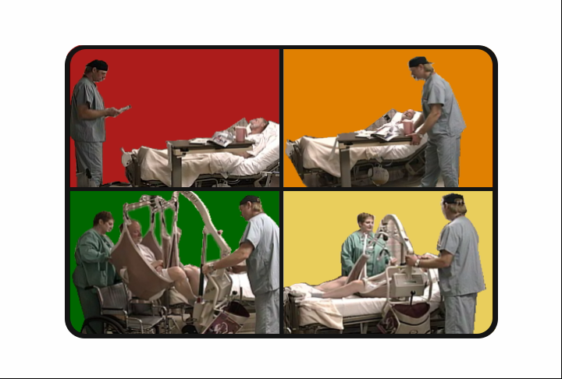

University of Oregon,
Labor Education and Research Center

This material has been made possible by a grant from Oregon Occupational Safety and Health Division (OR OSHA), Department of Consumer and Business Services

Any mention of Companies or brand names in these materials does not constitute endorsement of that company, equipment, or product by the Oregon Occupational Safety and Health Division, University of Oregon, or the Labor Education and Research Center (LERC). Citations to websites external to OR OSHA or the UO LERC do not constitute endorsement of the sponsoring organizations, their programs or products.

The information in this guide is intended to provide general guidance. However, workplace safety and health issues may be more complex than those presented in this guide. Seeking the advice of a professional ergonomist or other safety and health expert may be necessary.

Acknowledgements

This guide is the product of efforts by many individuals and organizations. It was developed by Jennifer A. Hess, DC, MPH, PhD, Research Associate at UO, LERC, in 2008 with the support of partners who have contributed time, insight, and materials to this guide. They include:

SAIF Corporation
Oregon Nurses Association
Oregon Coalition for Healthcare Ergonomics (OCHE)
OR OSHA
HumanFit

Table of Contents
Introduction to Safe Resident Handling (SRH) | 1
Why should Long Term Care Implement SRH programs? …..……………… | 1
What is Safe Resident Handling? .…………….…………………………….…. | 1
Target Audience …………………………………..……………………………… | 2
Purpose of this Guide ……………………………………………………………. | 2
Guide Objectives …………………………………….…………………………… | 3
Background ……………………………………………………………………….. | 3
Facility of Choice Certification ………………..………………………………… | 5
References ………………………...……………………………………………… | 6
Ergonomics Process Approach to Safe Resident Handling
The Safe Resident Handling Program Process Overview …………………… | 7
Step 1. Review Worker Injury Data and Establish Program Need ……….. . | 8
Step 2: Establish Management Support …………………………………….… | 10
Step 3: Form a Multidisciplinary SRH team ………………………………...… | 11
Step 4: Introduce Team to SRH Principles ………….………………………... | 13
Step 5: Educate Management and Obtain Approval for SPH Program …. | 14
Step 6: Develop SRH Program Business Plan ………………………………. | 16
Step 7: Ergonomics Training for the SRH team ……………………………… | 17
Step 8: Conduct Needs Assessments ……………………………………….... | 19
Step 9: Investigate Hazards: Ergonomic Risk Assessment ………………… | 20
Step 10: Formulate Solutions to Address Hazards …………………………... | 22
Step 11: Develop Implementation Plan ……………………………………….. | 26
Step 12: Evaluate Program Success ………………………………………….. | 28
Step 13: Sustain the SRH Program ………………………………………….… | 29
Appendices | 30
Appendix A Facility of Choice Certification Checklist
Appendix B Safe Resident Handling Components and Flow
Appendix C Injury Evaluation Tools
Safe Resident Handling Injury Measures Checklist
Facility Injury Data Tracking Sheet
Appendix D Data Collection Tools
Discrepancy Survey - Management
Discrepancy Survey - Staff
Symptom Survey
Resident Satisfaction Survey
Family Satisfaction Survey
Injury Data Breakdown
SRH worker input survey
Table of Contents (continued)
Appendix E Principles of SRH Evaluation Form
Appendix F Safe Resident Handling for Administrators Evaluation Form
Appendix G Needs Assessment Tools
Tool for Prioritizing High-Risk Resident Handling Tasks
Unit Profile and Space/Maintenance/Storage Evaluation
Administrative Checklist
Facilities Design Checklist
Equipment Use Inventory
Appendix H Ergonomic Risk Assessment
Ergonomic Observational Assessment
High Hazard Activities and Risk Factors (WISHA)
Ergonomic Training Evaluation Form
Summary of Resident Handling Needs and Risk
Appendix I Equipment Evaluation
Equipment Play Day Sign in Form
Product Feature Rating Form
Product Ranking Form
Equipment Purchase Considerations
Appendix J Template of Safe Resident Handling Policy
Appendix K SRH Program Implementation Time Line
Appendix L Competence Assessment
Appendix M Resources
Appendix N Definitions

Introduction to Safe Resident Handling

Why Safe Resident Handling Programs for Long Term Care?

In 2006, health care ranked second of 15 industries for non-fatal occupational injuries (BLS, 2007). A majority of these occupational injuries are work related musculoskeletal disorders (MSDs), such as strains and sprains, due to manual resident handling.

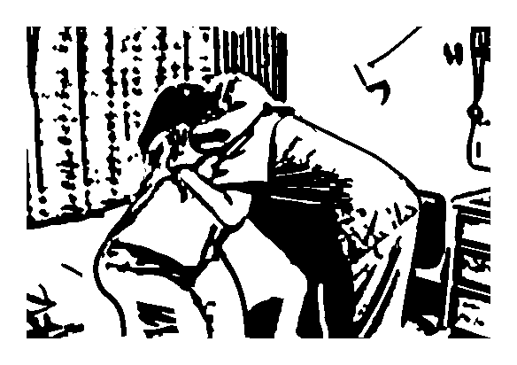
It has been demonstrated that there is no safe method for health care workers to manually lift or move a dependent resident. While proper body mechanics and lifting technique are important elements in reducing back stress, no amount of training will make lifting another person safe. Health care worker injury rates are especially high in long term care facilities (LTC), such as skilled nursing homes, assisted living facilities, and residential care facilities.

Residents are also at risk for injuries during manual lifts, transfers and other manual handling activities. They may become unstable and fall, and they may sustain bruises, skin tears, or abrasions during manual handling.

Yet, registered nurses (RNs), licensed nurse practitioners (LPNs), certified nursing assistants (CNAs), orderlies, and other care givers are routinely called upon to assist with lifting, transferring, and repositioning dependent residents. Further, LTC facilities have issues and concerns that differ from those of acute care hospitals. Safe Resident Handling (SRH) programs that address the specific needs of LTC are necessary to reduce injuries in workers and residents.

What Is Safe Resident Handling?

The National Institute for Occupational Safety and Health (NIOSH) states that the average person, when lifting another person, can safely lift only 35 lbs (Waters et al, 2007). Safe Resident Handling is an evidence-based ergonomic approach that emphasizes engineering and administrative solutions to risky resident handling activities. Such a program will involve changing the traditional way caregivers and residents think about lifting and moving activities.

Target Audience
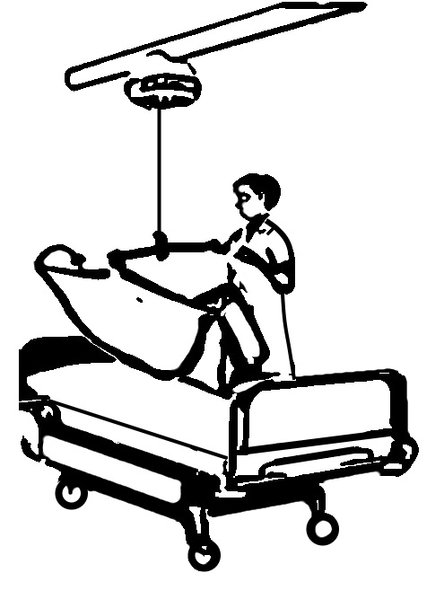
This guide is designed for use by those at long term care facilities such as skilled nursing homes, assisted living or residential care interested in transitioning their facility into a Facility of Choice for safe resident handling. It is intended to be used by interdisciplinary SRH teams which should be composed of people from

1) Management, including the director or an administrator, human resources, nurse managers

2) Care giving staff, including nurses, nursing aides, physical therapists, occupational therapists, transport technicians, and

3) Others involved in the use, maintenance and cleaning of equipment, such as facilities maintenance and laundry.

Purpose of this Guide

Studies by NIOSH have demonstrated a 30% decrease in resident handling injuries when SPH programs are implemented (NIOSH, 2002). These programs also result in better staff morale and improved resident comfort and safety. However, implementing a successful SRH program is more than just purchasing equipment. Implementing a SRH program will take time, money and the commitment of management and staff. The purpose of this guide is to provide step-by-step instructions to assist long term care facilities in developing an effective and sustainable SRH program. Three PowerPoint® trainings accompany this guide:
1) Principles of SRH
2) Safe Resident Handling for Administrators: Making the Business Case, and 3) Applied Ergonomics for LTC.

The chapters in this guide contain forms, templates and other tools to assist in developing and implementing a SRH program specific to LTC facilities.
A CD or an electronic copy of this guide are available from OR OSHA at www.cbs.state.or.us/osha/.
Many of the forms in this guide were developed by the Department of Veterans Affairs Patient Safety Center of Inquiry and can also be found at http://www.visn8.med.va.gov/patientsafetycenter/. Click on the link to “Safe Patient Movement and Handling.

Guide Objectives

This program guide will assist LTC personnel (management & labor) in creating a successful SRH ergonomics program by providing information to:

- Form a sustainable SRH team

- Define musculoskeletal injury risk factors associated with resident handling,

- Conduct an ergonomic hazard analysis of specific job resident handling activities including breaking job tasks down into steps, identifying risks, root causes, and potential solutions,

- Conduct several cost benefit analyses for estimating program cost and return on investment of the SRH program,

- Identify evidence-based engineering, administrative, and work practice solutions such as use of appropriate SPH equipment and modifying job tasks,

- Develop a SRH program plan and timeline,

- Implement the SRH program plan

- Evaluate the program

- Sustain the program

Attaining these objectives will decrease MSDs in caregivers, enhance workplace morale and create a safer environment for residents. Involving management and caregivers will foster a balanced approach to preventing musculoskeletal injuries.

Background

Resident handling activities place care givers at high risk for low back and other MSDs. These injuries are due to the physically demanding nature of the job that requires frequent manual lifting and transferring residents between beds, , wheelchairs, chairs or geris chairs, commodes, toilets and showers, and repositioning residents in beds. These activities exceed the physical capabilities of caregivers (Collins et al, 2004) and result in acute and cumulative musculoskeletal injuries. Nationally, overexertion injuries caused by lifting accounted for 48% of injuries in nursing and residential care facilities, and 43% injuries in hospitals (BLS, 2005).

Because of increasing demand for skilled care services and the increasing obesity of residents, the number of MSDs is expected to increase if workers continue to care for residents using manual handling methods. Yet, when comprehensive safe resident handling (SPH) programs with appropriate equipment are implemented worker injuries decrease. Moreover, evidence shows that SRH programs are practical and affordable. These programs are important for protecting workers from injuries associated with lifting and moving residents. For a variety of reasons, many long term care facilities (LTCF), including skilled nursing homes, assisted living facilities, and residential care facilities, have been yet to adopt SRH programs. It is time to move SRH programs from research and academic realms into field practice.

Data show that musculoskeletal injuries to RNs and CNAs are also a serious problem in Oregon, resulting in costly and disabling injuries to workers and to the residents being handled. Many of these injuries are associated with moving, transferring, and repositioning residents. Table 1 below shows the average number and percent of Accepted Disabling Workers Compensation Claims (ADCs) in Oregon for the years 2001 though 2006. Table 2 shows the actual dollar costs of all MSD injuries (disabling and non-disabling).

Table 1. Six Year Average ADC in Selected Health Care Facilities.
Facility Type | All ADCs | MSD ADCs | MSD % share of ADCs
Skilled Nursing Care Facilities | 1494 | 859 | 57.5
Intermediate Care Facilities | 233 | 136 | 58.4
Nursing & Personal Care Facilities | 181 | 93 | 51.4
Source: OR Dept. of Consumer & Business Services, IMD/R&A (01/23/07)

Table 2. MSD Costs in LTC, Intermediate and Skilled Nursing Facilities in Oregon
Injury Year Totals | Claim Incurred | Medical  Incurred | Time Loss Incurred | Time Loss Days
 | $ | $ | $ | #Days
2002 | 64,344,693 | 30,958,884 | 13,141,887 | 216,379
2003 | 68,062,157 | 32,756,861 | 13,559,371 | 212,358
2004 | 67,411,131 | 33,523,601 | 13,676,601 | 204,425
2005 | 64,090,019 | 33,420,719 | 12,492,442 | 176,410
2006 | 48,182,603 | 29,922,270 | 10,025,620 | 110,594
Grand Total | 312,090,602 | 160,582,334 | 62,895,922 | 920,166
Source: SAIF Corp, 02/09/07

These figures make it clear that MSDs account for the majority of injuries among Oregon workers in LTC facilities and the cost is staggering. Additionally, a survey of Oregon LTC facilities found that only 11% have a safe resident handling or “zero lift” policy, while 25% call Emergency Medical Services (EMS) for assistance when lifting a resident who has fallen to the floor (Hess and Kincl, 2006). This survey indicated that resident handling equipment and SRH programs were severely underutilized in these facilities.

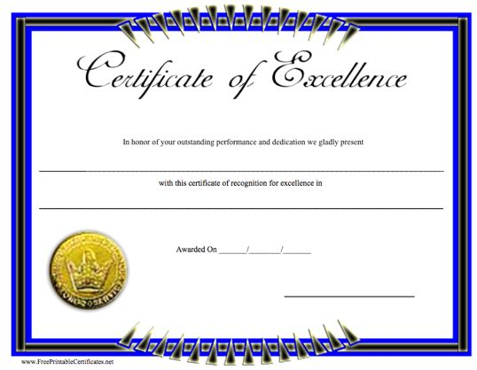
Facility of Choice Certification Criteria

The Facility of Choice (FOC) Certification is a new certification for long term care facilities much like the “Energy Star Certification” on appliances. Facilities can use the certification to attract more qualified, satisfied workers because these facilities will be ‘worker safe’ facilities. In LTC facilities worker turnover is high and retraining costly so this certification will be beneficial for reducing worker turnover. The Facility of Choice Certification may also be used to market potential ‘residents’ as a ‘resident safe’ facility, where “loved ones will receive the safest, state of the art care.” This will also be reflected in improved resident satisfaction related to enhanced quality of care. Criteria to qualify for Facility of Choice Certification are:

- The facility will implement a sustainable SRH program with shared responsibility among management and employees. The program will include an ongoing Safe Resident Handling Team that periodically evaluates job tasks and equipment use,
- Caregivers and other staff will be involved from the onset in the entire process, including identifying SRH issues in the facility and choosing equipment to trial.
- The facility will develop a ‘Safe Resident Handling Policy’ with worker input,
- Resident handling equipment will be purchased and/or installed for use throughout the facility for appropriate resident transfers,
- Workers proficient in ergonomics and equipment use will be required,
- There will be a program evaluation process that demonstrates effectiveness that includes: 1) effectiveness in reducing injuries and exposures to workers and residents, 2) worker and management involvement, 3) sustainability (active ergonomics committee, periodic hazard evaluations, etc.), 4) resident satisfaction, 5) worker satisfaction, and 6) return on investment (ROI).
A FOC Criteria checklist can be found in Appendix A and on the accompanying CD. For more information about the FOC contact the Oregon Occupational Safety and Health Association (OR OSHA) at www.cbs.state.or.us/osha/.

References

BLS, U.S. Dept of Labor, Bureau of Labor Statistics, (2005). Table R4. Number of nonfatal occupational injuries and illnesses involving days away from work by industry and selected events or exposures leading to injury or illness, 2005. http://www.bls.gov/iif/oshwc/osh/case/ostb1660.pdf

BLS, U.S. Dept of Labor, Bureau of Labor Statistics, 2007. BLS News, Nov, 2007
(http://www.bls.gov/iff/home/htm).

Collins, J.W., Wolf, L., Bell, J., Evanoff, B. (2004) An evaluation of a “Best Practices” Musculoskeletal Injury Prevention Programs in Nursing Homes. Injury Prevention, 10:206-211.

Hess JA, Kincl L, 2006, Survey Results from Washington and Oregon: How are LTC and EMS handling heavy residents? Oregon Coalition for Healthcare Ergonomics Conference, Portland, OR.

Veterans Health Administration, (VA) (2001), Resident Care Ergonomics Resource Guide: Safe Resident Handling and Movement, Department of Veterans Affairs.
http://www.visn8.med.va.gov/residentsafetycenter/safePtHandling/default.asp

Waters T, 2007 When is it Safe to Manually Lift a Resident? Am J Nursing, 107(8): 53-59.

Ergonomics Process Approach to Safe Resident Handling

Safe Resident Handling Program Process Overview


In the past hospitals and long term care facilities have purchased patient/resident handling equipment only to find portable lifts gathering dust in the back of closets, batteries exhausted, and slings lost. Therefore, the appropriate foundation must be laid to ensure success. A process approach to SRH involves all users in a systematic way. A process approach includes information for defining the problem, involving management and workers on the need for a SRH program, training for workers on identifying, and prioritizing ergonomic hazards, and a systematic approach to developing and implementing viable solutions. The effect of a process approach to SRH is cost justification of the program, enhanced acceptance by workers and residents, and a sustainable program that results in reduced levels of injury to workers and residents. This guide will follow the thirteen step process approach outlined below. These steps are only a guide and some of these steps can be conducted concurrently. Your facility may take more or less time to complete these steps. Additionally, evaluation should be conducted annually or semi-annually and appropriate changes made to keep the SRH program viable.

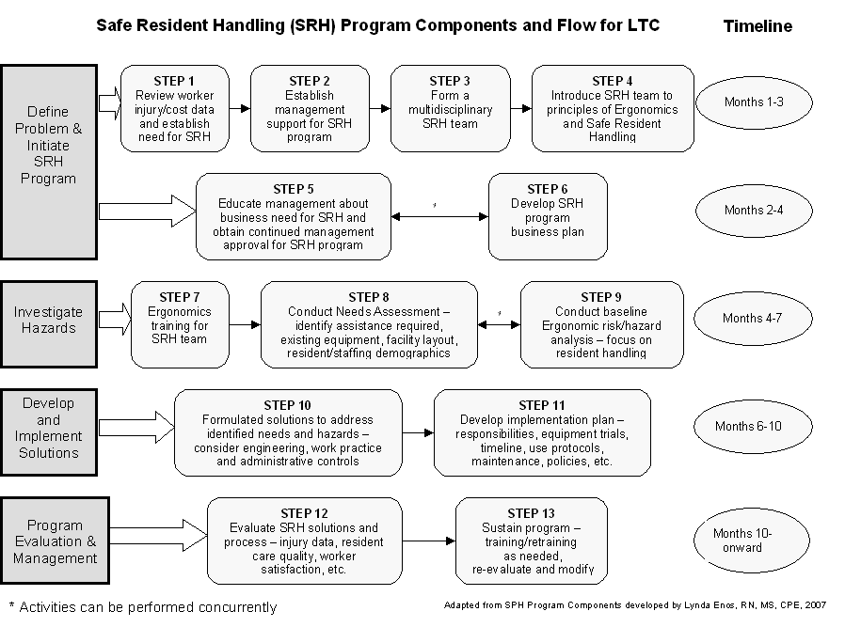
The SRH Program Components and Flow handout can also be found in Appendix B and on the accompanying CD

Ergonomics Process Approach to Safe Resident Handling

Step 1: Review Worker Injury Data and Establish Program Need

Prior to choosing solutions it is necessary to know what types of resident handling injuries are most common and severe. This information can be obtained from workers compensation data and OR OSHA 300 logs.

This information is gathered at the beginning of the program to provide a comparison with the same type of data collected periodically after implementing the SRH program. This provides a measure of program effectiveness which will be useful for seeing areas that need additional improvement.

There are several types of injury data that should be collected, including numbers and rates of resident handling related injuries, time loss day, restricted work days, and injury costs.
The CD that accompanies this guide contains an Excel® document called “Injury Calculation Worksheet” to assist with calculating injury rates and costs and creating figures. An example of the worksheet in Microsoft Word® format is provided in Appendix C.

In addition to injury rates, worker input, changes in worker satisfaction and turnover rates, resident and family satisfaction, and resident quality of care indicators are important measures of facility improvement associated with a SRH program. The “SRH Injury Measures Checklist” provides a complete list of the data that should be collected at the beginning the SRH program. This data should also be collected after implementing the program and again in one year, then annually, for at least three years.
The “SRH Injury Measures Checklist” can be found in Appendix C and on the accompanying CD.

Several other data collection forms are needed in order to collect baseline information. These documents include:

- Types of worker injuries chart
- Discrepancy surveys (one for management and one for staff) – administered to all management and staff to gauge the current level of satisfaction with resident handling issues at the facility
- Symptom survey – to be completed by care giving staff
- Resident satisfaction survey – administered by a nurse or care giver to residents who receive assistance in being moved or lifted,
- Family satisfaction survey - administered by a nurse or care giver to family member of residents who receive assistance in being moved or lifted,
- SRH worker input questionnaire

These questionnaires should be administered to the appropriate people at the start of the SRH program, then following the implementation of the SRH program, usually in about one year. They should also be administered annually to keep track of improvements or problems that may develop.

These questionnaires can be found in Appendix D and on the accompanying CD. They are Microsoft Word® Word documents and can be reformatted as needed.

Additional helpful questionnaires are available from the Veterans Health Administration:
http://www.visn8.med.va.gov/residentsafetycenter/safePtHandling/default.asp

Ergonomics Process Approach to Safe Resident Handling

Step 2: Establish Management Support of SRH Program

The drive to establish a SRH program can be initiated by direct care staff, such as an RN, LPN or CNA, someone in management, such as Human Resource Director. An overview of injury statistics can confirm rates of musculoskeletal disorders (MSDs), costs, and time loss associated with these injuries and provides initial evidence of the need for a SRH program.

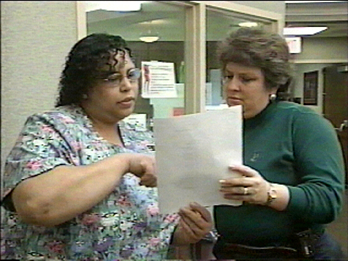
Sometimes upper management is aware there are too many injuries but they do not know how to proceed. Once there is interest in developing a SRH program it is essential to meet with management to gain support from top management in order to proceed with developing a SRH program. If management is not aware of injury data associated with resident handling, present this data, and then provide an overview of the SRH program process that should be undertaken using the SHR program components and flow chart. Developing a SRH program will take the time and involvement by staff throughout the facility so it is important so that everyone has realistic expectations.

Ergonomics Process Approach to Safe Resident Handling

Step 3: Form a Multidisciplinary SRH Team

Once the support of top management has been gained, a SRH committee or team should be assembled. This team should represent all areas of the facility. Some potential team members are:

- Administrators
- Human Resources
- CNAs, LPNs, RNs and other care giving staff
- Charge nurses or nurse managers
- Physical Therapy/Occupational Therapy
- Maintenance/plant operations
- Laundry
- Purchasing

Consider having some duplication of personnel to distribute the workload and ensure that all shifts are represented. Early in the development of the SRH team ‘champions’ or ‘team leaders’ should be identified. These are individuals who believe in the program and will promote it among co-workers.

Additionally ergonomics consultants can help facilitate the process. In Oregon, OSHA provides ergonomic consultants; workers compensation insurers such as SAIF Corporation and Liberty Mutual also provide ergonomics consulting.

The SRH team will be the body that develops and implements the SRH program.
They should plan to meet weekly at first.

Their first jobs should be to
- Develop vision and mission statements
- Create a SRH team name and logo
- Discuss and decide upon program goals: short term and long term
- Consider barriers and challenges that will have to be overcome
- Decide on communication channels among the SRH team and the facility

A sample vision statement: Develop a Safe Resident Handling program focused on the safety of residents and staff that will produce a sustainable and proactive best practices culture change. This will be done through open communication and accountability to the pilot project.

A sample mission statement: The mission of our safe resident handling team is to 1) implement a SRH program, 2) create awareness about SRH, 3) Facilitate accountability, 4) reduce the incidence and severity of MSDs in all nursing and resident care staff. Components of the mission statement can be more extensive.

Examples of Team Names and Acronyms:
SWAT – Safe Area Work Team
COPS – Caregivers Organize for Patient Safety
SMART – Safe Movement Awareness Resource Team



Examples of program goals:
Short term goals – within first year of implementing SRH program
- Reduce incidence of MSDs in workers associated with resident handling by 25%
- Reduce number of lost work days related to resident handling by 25%
- Reduce resident falls related to handling by 10%
- Reduce pressure ulcers and other resident quality indicators 10%
- Develop an ‘ergonomics culture’ in all management & staff
- Increase care giver time with residents by 20% in first year
- Identify and prioritize ‘high risk’ residents at admission

Long-term goals - years 2-3 and beyond
- Reduce cost of workers compensation claims by 50%
- Decrease lost work days by 50%
- Reduce restricted work days by 50%

Barriers and Challenges

Some common barriers and challenges include:
- Resistance to change by caregivers
- Resistance to using equipment by residents
- Physical limitation of building structure
- Cost of equipment
- Making time for SRH team to get program running.

Ergonomics Process Approach to Safe Resident Handling

Step 4: Introduce Team to SRH Principles

Using a process approach to ergonomics is new to many people in the long term care industry. A process approach requires involvement by staff at all levels of the facility, management commitment to the program, time for staff to develop and implement the program, an organized plan to accomplish the program, and funding. To introduce the SRH team to the principles of ergonomics and a process approach to a SRH program, a 4-hour Power Point® presentation titled “Principles of Safe Resident Handling” has been developed.

This training provides an overview of ergonomic risk factors and why resident handling is dangerous, recent injury statistics from Oregon Long Term Care facilities, reasons why some programs fail or succeed, an overview of SRH equipment, and an introduction to the process approach. This presentation also includes time for group discussions to initiate the SRH program, such as choosing a team name and logo, and developing mission statement and goals. This presentation should be presented as soon as the SRH team is formed, in the first months of the program.
“Principles of Safe Resident Handling” is included on the CD that accompanies this guide

Ergonomists from OR OSHA or loss control personnel from workers compensation providers such as SAIF Corporation or Liberty Mutual are available to assist with this presentation, as well as the two other presentations that accompany this guide, “Safe Resident Handling for Administrators: Making the Business Case” and “Applied Ergonomics for Long Term Care”.
An evaluation form to assess how much the team learned is included in Appendix E and on the accompanying CD.

Ergonomics Process Approach to Safe Resident Handling

Step 5: Educate Management and Obtain Final Management Approval for SPH Program

In many cases administrators do not address safety related hazards unless required by state, federal or licensing requirements. Administrators are often more concerned about staffing, accreditation and consumer demand than employee injuries or OSHA regulations (Fell-Carlson, 2005). Yet, there is evidence that SRH programs can address those concerns as well as improve safety. In Ohio, the Wyandot County long-term care facility, after adopting a SRH program, reported no MSDs in over nine years, lower turnover, and an attractive pool of prospective employees.

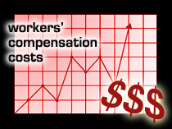
From a business perspective SRH programs are cost effective. Research has shown that the payback period for return on investment associated with equipment purchase is usually less than 3 years (Collins et al., 2004; Tiesman, Nelson, Charney, Siddharthan, & Fragala, 2003). The National Institute of Occupational Safety and Health (NIOSH) reports that an initial investment of about $158,000 for patient handling equipment and worker training can be recovered in less than 3 years based on an estimated $55,000 annual savings in workers' compensation costs (Collins et al., 2004).

The business case goes beyond demonstrating a return on investment and includes demonstrating other types of savings such as reductions in time loss, retraining costs, enhanced worker retention, and improved resident satisfaction. The Wyandot County Nursing home in Ohio demonstrated that a $406,000 investment over four years resulted in $251,000 in savings; much of this was from decreases in workers compensation costs, staff turn-over costs, retraining costs, and overtime costs.

In order for any SRH program to be effective, CEOs and administrators need to be convinced that adopting a SRH program makes “good business sense.” While these programs cost money and take time and the commitment of management and staff, ultimately they are beneficial, resulting in cost savings, improved worker satisfaction, retention and morale, and enhanced resident satisfaction.

The 2-hour PowerPoint® presentation “Safe Resident Handling for Administrators: Making the Business Case” provides an overview of ergonomic risk factors, plus information about the importance of implementing a SRH program. It provides tools to assist administrators in calculating the Return on Investment (ROI), Cost Benefit Ratio, Payback Period, Profit Margin Analysis, Incidence and Severity Rates and more.
“Safe Resident Handling for Administrators: Making the Business Case” is included on the CD that accompanies this guide

An evaluation form to assess how much administrators learned during the training is included in Appendix F and on the accompanying CD.

References

Fell-Carlson D, Evidence-based Safe Patient Handling: A Proposed Conceptual Model for Knowledge Transfer and Executive-level Decision-making, Project, OSU, 2005

Collins, J.W., Wolf, L., Bell, J., Evanoff, B. (2004) An evaluation of a “Best Practices” Musculoskeletal Injury Prevention Programs in Nursing Homes. Injury Prevention, 10:206-211.
Tiesman, H., Nelson, A., Charney, W., Siddharthan, K., & Fragala, G. (2003). Effectiveness of a ceiling-mounted patient lift system in reducing occupational injuries in long term care. Journal of Healthcare and Safety, 1(1): 34-40.

Ergonomics Process Approach to Safe Resident Handling

Program costs?
Step 6: Develop a SRH Program Business Plan
Staff Time?
Long term care facilities, as businesses, are concerned about the ways new programs affects the business. They want to know about disruptions in work flow, costs, and potential benefits from the program. Therefore, it is important to develop a document that addresses concerns from a business perspective. This involves putting the SRH Program Components into written form that can be presented to upper management for their review and approval. Such a written business plan is useful for laying out expectations, costs, responsibilities, and benefits of the program. This information will assist management in “selling” the program to their governing board and others involved in making budget and planning decisions.

The business plan should contain the following elements:

- Program vision and mission statements
- Goals, both short and long term
- Program structure - this defines SHR team members and responsibilities of members for program development and implementation
- Training plan – types of training for the SRH team and management
- Injury data collection plan – what will be collected, by whom and when
- Ergonomic assessment plan – based upon ergonomic hazard or risk assessments conducted by the SRH team
- Barriers - to successful program implementation that will need to be addressed to ensure success
- Communication channels – an outline for how SRH team members will communication with each other, management, staff, and residents
- Program budget and justification – this will develop over time and should prioritize SRH needs for equipment
- Solutions – should spell out the ergonomic solutions developed by the SHR team, including equipment, work practice changes, and policy changes
- Solution implementation plan – explains how solutions will be implemented with minimal disruption to the facility
- Timeline for completion of the project, based on the SRH Components and Flow and solution implementation plan
- Evaluation and sustainability – outlines the post implementation evaluation and measures to keep the program active and ongoing

Ergonomics Process Approach to Safe Resident Handling

Step 7: Ergonomics Training for the SRH Team

Ergonomics

Ergonomics is the process of designing jobs that fit the workers rather than expecting workers to adapt to poor work designs. Workers come in all ages, sizes, shapes, and physical capacities. Manual handling of residents is unsafe because it requires caregivers to perform tasks beyond their physical capabilities. The risk factors associated with resident handling include awkward, sometimes prolonged postures, use of high forces when lifting or moving residents, and repetitive activities. Awkward postures are positions beyond the body’s’ neutral position, which is when a person stands erect with the arms at the sides of the body. High forces occur when lifting more than about 35 pounds when moving a person. A good example of an awkward posture with high forces is moving a dependent resident between a bed and a wheelchair. An example of a prolonged posture occurs while bending over a resident to provide care.

Body Mechanics

Body mechanics is the process of applying mechanical laws to the human body to optimize function during movement, lifting, pushing, pulling and other work activities in order to minimize the risk of musculoskeletal injury. Body mechanics training was popular in the 1980s as a means of preventing workplace injuries. However, research has demonstrated that body mechanics alone will not prevent musculoskeletal injuries. No matter how hard a caregiver tries to use good body mechanics, repetitively performing resident care lifts and transfers, compounds risk factors and leads to cumulative damage to the muscles, ligaments, and discs, and eventual injury to the muscles, ligaments, discs and joints.

Depending upon the size of your SRH team, an ergonomics team could be composed of a subset of the SRH team, but in any case, should be made up of 4-5 individuals from the SRH team including at least one person from nursing management and the caregiver staff. The ergonomics team will receive additional ergonomics training provided by the PowerPoint® presentation “Applied Ergonomics for Long Term Care.” This is a 2-3 hour training module that defines and explains ergonomics, cumulative trauma injuries, reviews the risk factors associated with these musculoskeletal disorders (MSDs), highlights different types of ergonomic controls, such as engineering, administrative, work practice, and behavior controls, and emphasizes that engineering and administrative controls are the most effective solutions for preventing MSDs.
“Applied Ergonomics for Long Term Care” is provided on the CD

The presentation incorporates the format and video from the Safe Patient Handling in Health Care: Applied Ergonomics for Nurses and Health Care Workers and Patient Orientation using the following 4-steps:
- Assess the Resident
- Assess and Prepare the Environment
- Get Necessary Equipment and Help
- Perform the Resident Care Task Safely

The Ergonomic Risk Assessment handouts for the training and an evaluation form are in Appendix H and on the CD.

Use the patient handling scenarios on the video to complete the Ergonomic Observational Assessment Form. While the video contains six scenarios, expect to only have time to go through three or four. You can use the video and scenarios for future refresher classes.

The Safe Patient Handling in Health Care binder and video can be obtained from the Oregon Nurses Association at www.oregonrn.org/ or from OR OSHA at www.cbs.state.or.us/osha/.

Ergonomics Process Approach to Safe Resident Handling

Step 8: Conduct Baseline Needs Assessment

It will be important to evaluate aspects of the facility such as issues with existing equipment, space and storage availability, facility design limitations, and maintenance and repair concerns.

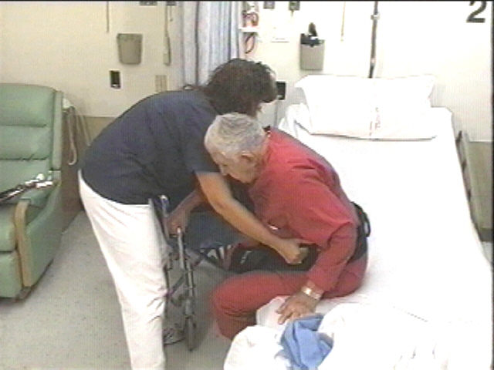
Assessment tools include:
In order to facilitate the needs assessment five evaluation tools have been included in Appendix G and on the accompanying CD.

- Tool for Prioritizing High-Risk Resident Handling Tasks
- Unit Profile and Space/Maintenance/Storage Evaluation
- Administrative Checklist
- Facilities Design Checklist
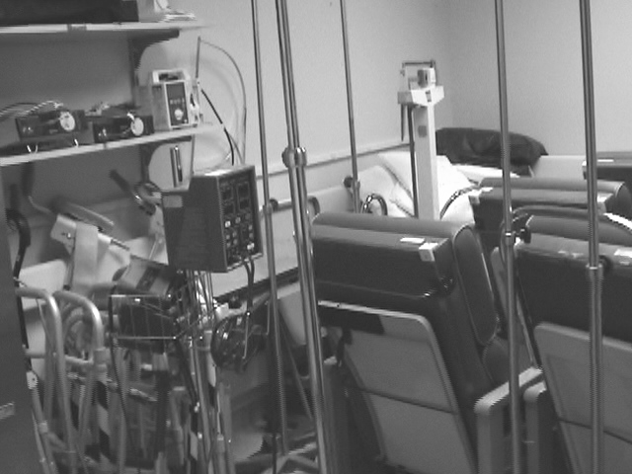
- Equipment Inventory

Your facility may not need to use all of these tools, they are provided to assist you with a comprehensive and systematic approach to looking at your facility from a variety of perspectives.

Upon completion of the needs assessment the SRH team should conduct an ergonomic risk assessment. At that point sufficient information will be available to summarize your needs and risk and begin formulating solutions.

Ergonomics Process Approach to Safe Resident Handling

Step 9: Investigate Hazards: Ergonomic Risk Assessment

After completing the ergonomics training module the ergonomics team should conduct site visits or ‘Ergonomics Observational Assessments’ of all facility wings or units. The purpose of conducting these assessments is to get an idea of the types of injury risks to caregivers associated with lifting, moving, or transferring residents and to determine what improvements could be implemented to decrease the risk of injury to caregivers and residents. In order to gain a comprehensive view of these risks it is important to sample a variety of conditions and situations common to your facility. Some common conditions you should consider sampling are:

- Different types of resident requirements/needs
  - Dependent and semi-dependent
  - Manual vs. equipment transfers
  - Aggressive or unpredictable
  - Dementia or inability to follow directions

- Different room configurations
  - Different room shapes and furniture (pick a couple of common room types, or especially problematic rooms)
  - Beds in different locations
  - Residents on low beds that do not adjust or are on floor

- Different caregiver sizes (observe several different caregivers)

- Different shifts (are there any differences based on shift?)

- Different types of resident handling
  - Bed to wheelchair or wheelchair to bed
  - Wheelchair to chair or chair to wheelchair
  - Wheelchair to toilet
  - Wheelchair to shower
  - Lateral supine transfer (gurney to bed or visa versa)
  - Reposition in bed (moving them up in bed)
  - Turning resident in bed

If there are other unique situations consider conducting a risk assessment to capture potential risk. Think about your facility and add to this list if needed.

The ergonomic teams should work in pairs of two to three. If you observe a transfer being performed by two caregivers, choose the primary caregiver to observe. Before the transfer, record as much information as possible on your observation sheet, such as type of activity (wheelchair to bed), number of time a day the person is transferred, etc. Then watch the activity, when it is complete step out of the room and immediately write down what you observed. Break the job down into 2-4 tasks (preparation, transfer, positioning in bed), record the risk factors to the caregiver (awkward postures, static/prolonged postures, heavy weight of resident), the root cause (resident too dependent for manual transfer, room too crowded, etc.) and possible solutions (move clutter out of the way, use equipment, etc.). Then, the two ergo team members should discuss what was seen and record any additional information that comes from that discussion. Given the list above of different situations, you may need to conduct about 15-20 ergonomic assessments, but there is no set number. The important thing to consider is whether the ergo team has conducted enough assessments to have a good idea of all the different types of problems and issues in your facility. You can always do more assessments.

Try to complete all the assessments in with in two to three weeks of the completing the ergonomics training, and be sure to sample from multiple shifts and different types of resident room configurations.

Be sure to copy one Observational Assessment form and several worksheets for each person on the Ergonomics Team.

The Ergonomic Observational Assessment form and additional worksheets for conducting these evaluations can be found in Appendix H and on the CD.

After the needs assessment and the ergonomic risk assessment have been completed the information can be summarized in the “Summary of Facility Needs and Risk form included in appendix H and on the CD. This information, combined with injury data provides a comprehensive picture of your facilities needs and concerns. All this information should be discussed by the SRH team, to provide a comprehensive picture of your facilities needs and concerns. This information is used to formulate solutions.

Ergonomics Process Approach to Safe Resident Handling

Step 10: Formulate Solutions to Address Hazards

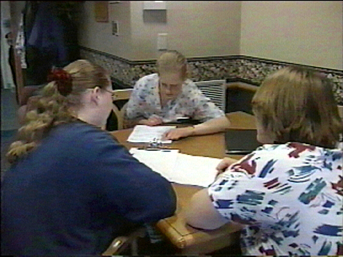
Once the risk analysis has been completed the SRH team will be able to begin formulating solutions. When developing solutions it may be necessary to consider constraints, such as fiscal resources and the physical limitations of the building. In general, solutions will be of two types: engineering controls or administrative controls. Engineering controls are solutions that require physical modification in equipment or the workplace, such as installing ceiling lifts, purchasing portable lifts, slide sheets and transfer belts. Administrative controls usually refer to changes in work practices and policies. Examples of administrative controls are changes in scheduling, job rotation, and policies about resident handling practices.

Selection of the appropriate resident transfer aids should be based upon dependency levels of residents. A facility may use the dependency levels established for resident care plans which frequently breakdown dependency into five levels or you may choose to use the guidelines established by the VA specifically for lifting and moving residents:

- Independent— Resident performs task safely, with or without staff assistance or assistive devices.

- Partial Assist—Resident requires no more help than stand-by, cueing, or coaxing, or caregiver is required to lift no more than 35 lbs. of a resident’s weight.

- Dependent—Resident requires nurse to lift more than 35 lbs. of the resident’s weight, or is unpredictable in the amount of assistance offered.

Algorithms for safe resident handling and movement, developed by the VA are included on the accompanying CD or from the VA at: http://www.visn8.med.va.gov/residentsafetycenter/safePtHandling/default.asp/.

Equipment Trials

At the point where the SRH team begins conducting observational risk assessments it is a good time to schedule an “Equipment Play Day” with a vendor. This is a day when different types of resident handling equipment are brought to the facility. The vendor may provide introductory training on safe use of the equipment and workers have a chance to experience the equipment first hand. Some equipment that should be included in an initial play day is:
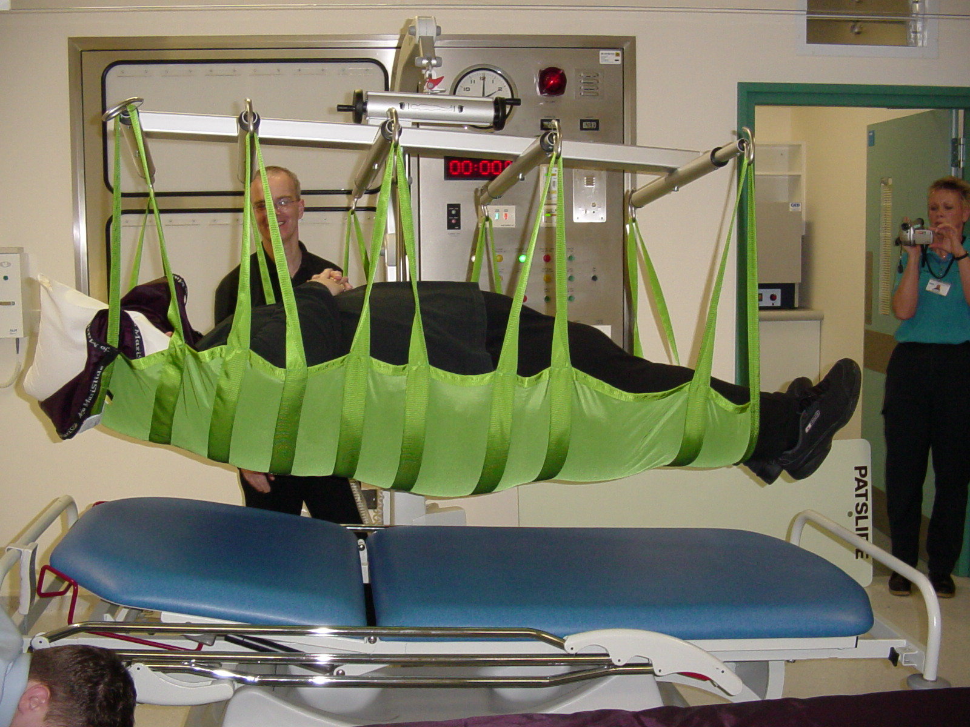
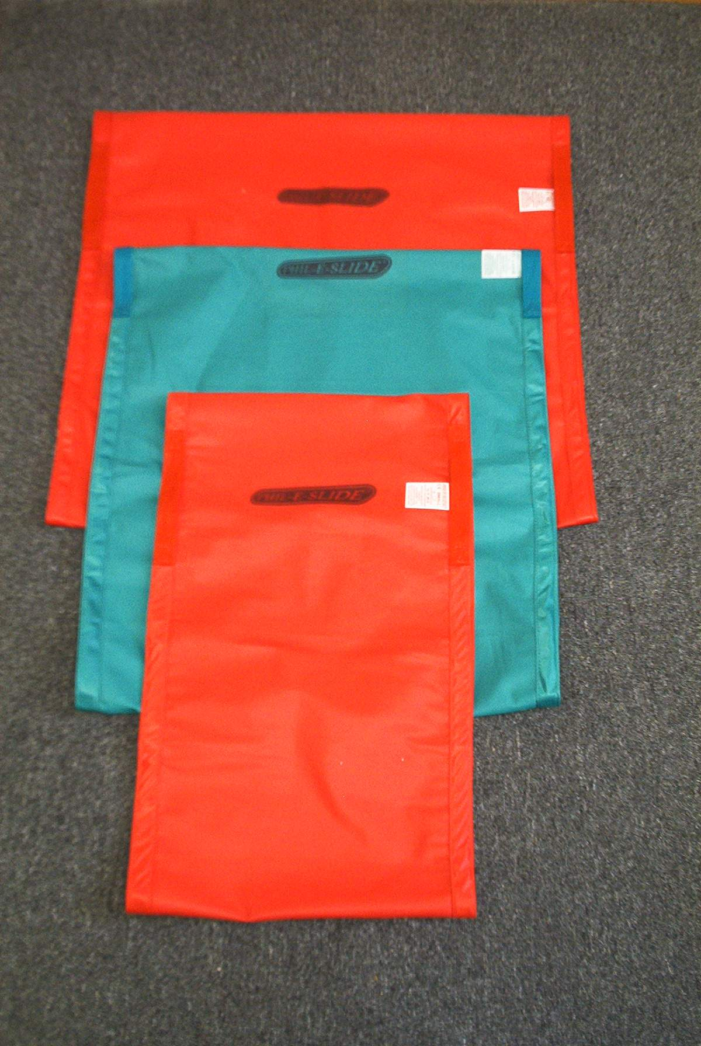
- Portable ceiling tracking lift with various types of slings (seated, flat or supine)
- Portable powered floor lifts
- Portable powered and non powered sit-to-stand equipment
- A variety of friction reducing lateral transfer devices (i.e. slide sheets)
- Equipment to get residents off the floor (such as a floor lift)
- A variety of wide gait belts with handles

Workers should be scheduled throughout the day, with time to spend at least an hour each, learning about and trying equipment. It is important to schedule additional workers to cover shifts while workers rotate into and out of the equipment room.
Forms for “Equipment Day” sign in and two equipment rating forms, developed by the VA, are in Appendix I, as well as on the accompanying CD.

Once the needs assessments and ergonomic risk assessments have been completed and workers have had a chance to learn about types of equipment available during the “Equipment Play Day” it will be time for the SRH team to begin to seriously consider their equipment needs. Several manufacturers of equipment should be considered. After investigating equipment on the internet, and talking to vendors on the phone, two or three equipment vendors should be invited to the facility, for in-depth ‘Equipment Day’ demonstrations of the equipment to the care giving staff and the SRH team. Ceiling track systems, portable equipment, and low tech equipment, such as friction reducing devices should all be investigated. This is the time to thoroughly examine important aspects of the equipment such as equipment ease of use and versatility; battery life and method for charging batteries; sling compatibility and laundering restrictions. Vendors should also be provide detailed information about equipment warranties, equipment certification (UL or other), post-purchase service agreements, experience of installers with that particular equipment and meeting regulations within the state.

An Equipment Purchasing Considerations form is provided in Appendix I, as well as on the accompanying CD. This is NOT a comprehensive list but does provide a starting point for talking with vendors.

Selecting a Vendor

When deciding on types, quantities, and costs of equipment several vendors should be consulted to obtain comparative quotations and to allow staff to explore equipment features. Most equipment can and should be trialed in your facility prior to selection of large quantities. The “Technology Resource Guide” created by the VA and updated in April 2008, is a 65 page document describing resident handling equipment, its use and advantages, and it provides an extensive list of equipment vendors. Some vendors who sell and install ceiling lift systems and other resident handling equipment in Oregon are:

- Alpha Modalities: www.alphamodalities.com
- Liko: www.Liko.com
- Medcare Inc: www.medcarelifts.com
- EZ Way, Inc: www.ezlifts.com
- ARJO: www.arjo.com

This is not an exhaustive list, nor is any particular vendor recommended. This list is provided to assist the SRH team in getting started looking at equipment on the internet and talking with vendors.

The Technology Resource Guide created by the VA is provided on the accompanying CD and is available from the VA at: http://www.visn8.med.va.gov/residentsafetycenter/safePtHandling/default.asp

The following selection criteria, for lifting and transferring equipment, are provided by the VA:

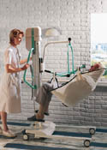
1. The devices should be appropriate for the task that is to be accomplished.

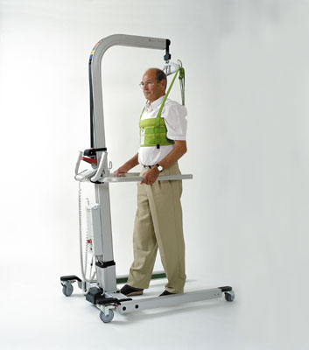
2. The device must be safe for both the patient and the caregiver. It must be stable, strong enough to secure and hold the patient, and permit the caregiver to use good body mechanics.

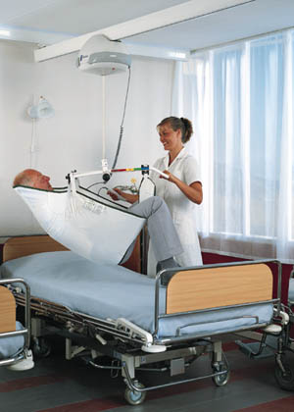
3. The device must be comfortable for the patient. It should not produce or intensify pain, contribute to bruising of the skin, or tear the skin.

4. The device should be understood and managed with relative ease.

5. The device must be efficient in the use of time.
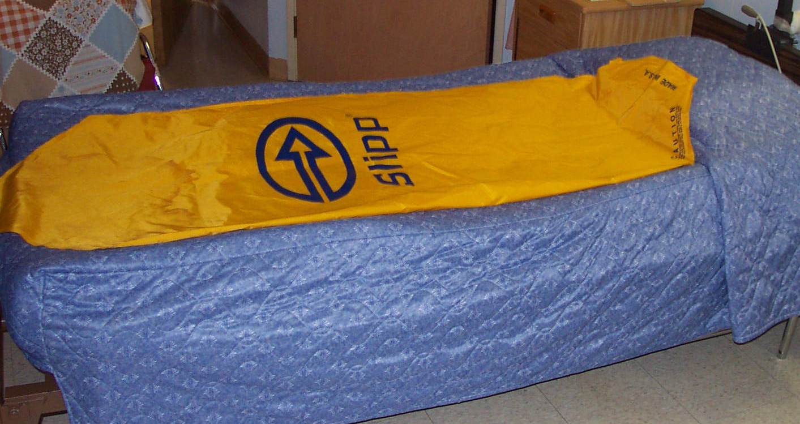
6. Need for maintenance should be minimal.

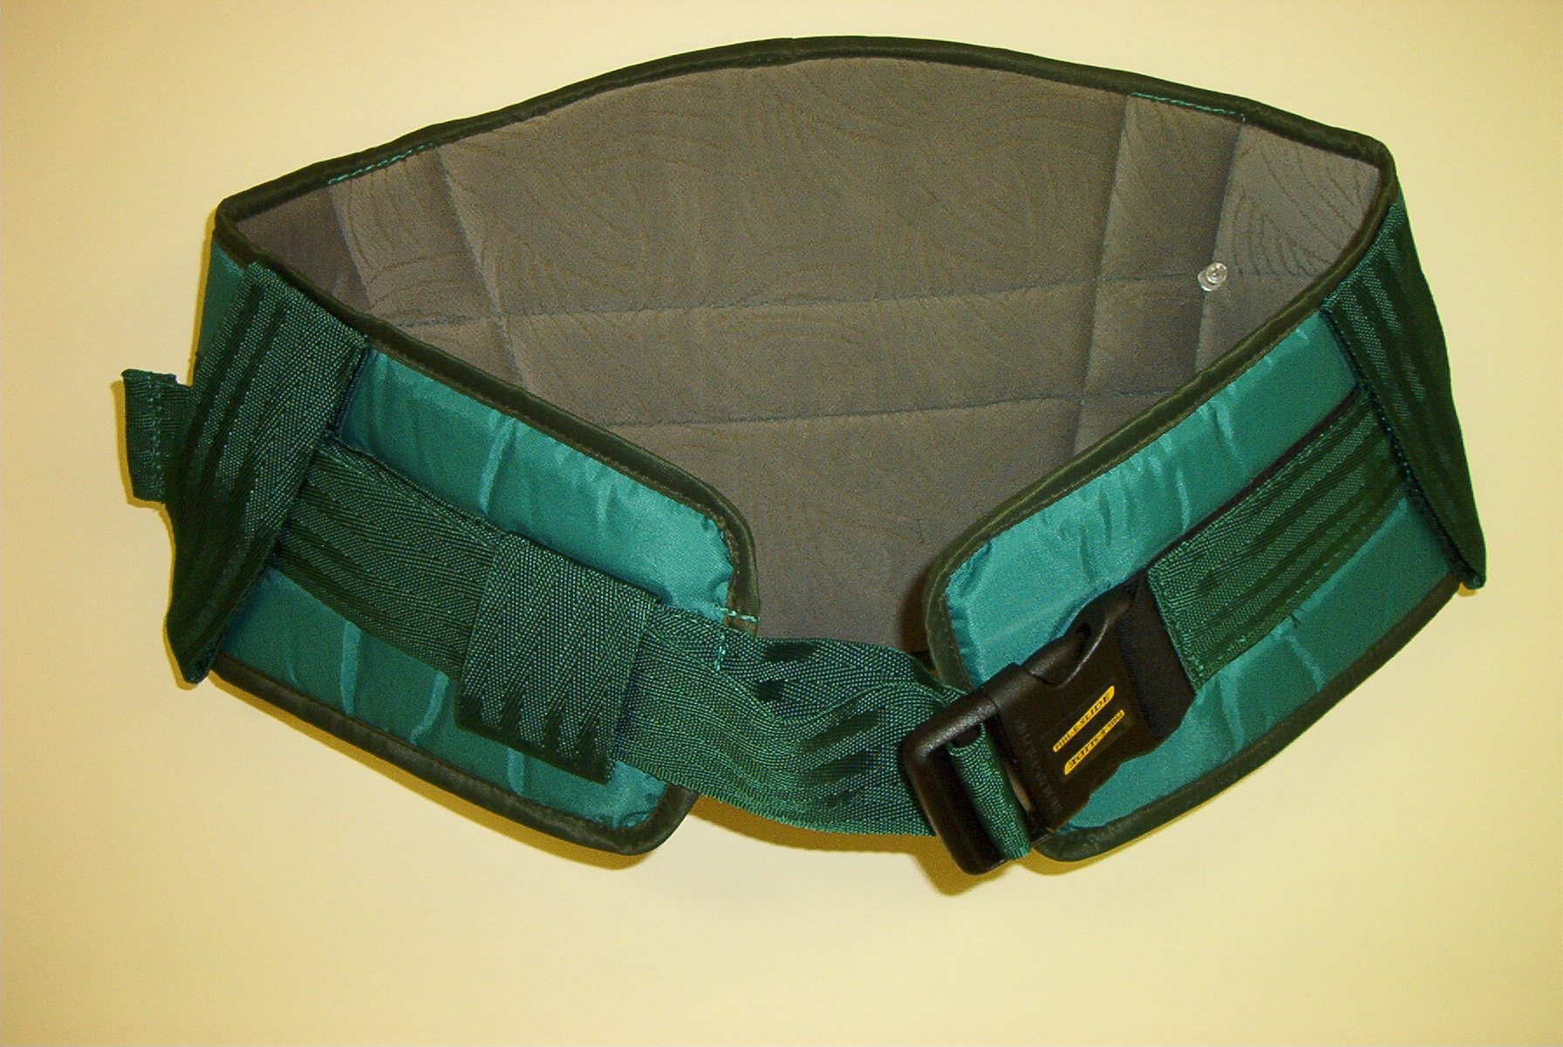
7. Storage requirements should be reasonable.

8. The device must be maneuverable in a confined workspace.

9. The device should be versatile.

10. The device must be able to be kept clean easily.

11. The device must be adequate in number so that it is accessible.

12. Cost.

- For ceiling lifts, ensure that the vendor employs installers licensed and bonded in the state who have experience installing ceiling lifts
Equipment rating and ranking forms, and an equipment purchase consideration form, found in Appendix I, should be used to evaluate portable equipment and ceiling track systems under consideration.

Written SRH Program Policy

An important part of a SRH program is development and implementation of a “Safe Resident Handling” policy. The purpose of the policy is to clearly define acceptable resident handling policies and to support staff and administration in adhering to established practices. The policy should spell out duties for caregivers, supervisors and others.
Appendix J and the accompanying CD provide a sample SRH policy created by the Department of Veterans Affairs: http://www.visn8.med.va.gov/patientsafetycenter/.
Ergonomics Process Approach to Safe Resident Handling

Step 11: Develop Implementation Plan

When the SRH team completes formulation of the SRH solutions a detailed plan to implement those solutions will need to be developed in order to have a smooth transition, implementation, and to enhance the chance of a successful and well accepted program. This will include a timeline for purchasing equipment installing ceiling tracking, if applicable, and training for caregivers on equipment use. An implementation team may be a subgroup of the SRH team.

Timeline

The timeline should be detailed and well publicized within the facility among staff and residents. All end users should have input and be involved in the process in order to ensure a smooth transition. The timeline for your facility may be shorter and involve more or less steps than those provided in the sample timeline.
A sample SRH program timeline is provided in Appendix K and on the accompanying CD.

Training

As the SRH program is implemented there will be a dizzying array of new equipment for caregivers and other staff to sort out. Therefore, once equipment is purchased, part of the implementation process should be competency training for all caregivers. It will take more than one session per care giver to become competent in using the equipment safely; it is important to allow for sufficient training time in your implementation plan.
A Competence Assessment, developed by the VA, is provided in Appendix L an on the accompanying CD.

Implemented is a good time for a review of ergonomics for the SRH team and management. There should be a facility-wide introductory ergonomics training for all staff. An OR OSHA ergonomist or a workers compensation loss control representative can assist with these classes.

It will also be important to plan education and awareness training and activities for the residents and their families. There could be resistance by some residents or their families to the use of unfamiliar equipment. They need to be made aware that use of equipment is safer, more comfortable and more dignified. Contained in the “Safe Patient Handling in Health Care: Applied Ergonomics for Nurses and Health Care Workers and Patient Orientation” binder is a video designed to enhance resident and family awareness about the use of equipment. This is a good starting place, but the SRH team should develop facility specific tools, information, and dissemination plans. There should be plans for talking with potential new residents about resident handling policies and the types of lifting and moving equipment used in the facility.

Facilities, Maintenance, Laundry, and Other Issues

Facilities, maintenance and laundry should be involved in the implementation process. Plans will have to be created to store some equipment in rooms, such as friction reducing lateral transfer sheet and transfer belts, while other equipment, such as portable lifts, sit-to-stand lifts or ceiling track motors will need to be stored in easily accessible central locations on each wing or unit. This may require relocating other materials and in extreme cases, may require unit redesign and construction.

A schedule for making sure equipment is safe and in working order should be created, that ensures that equipment is maintained regularly. Portable equipment has wheels that will need to be cleaned and maintained and may have batteries that will need to be plugged into an outlet and charged regularly, so a process and responsibilities will need to be part of the implementation process. Spare batteries will likely be needed.

Since slings will need to be laundered, a process will need to be devised for getting slings to and from the laundry in a timely manner and for extra slings to be available while slings are laundered. Slings will also need to be inspected regularly for frayed straps and other wear that could make them unsuitable for use. A system for regularly checking slings should be devised.

Lastly, since the SRH program is an ongoing process, the plan should include steps and a timeline for changes that cannot be immediately implemented, but which will be introduced over time. This could include facilities design considerations for future additions and remodels.
Ergonomics Process Approach to Safe Resident Handling

Step 12: Evaluate SRH Process

In order to know whether your program is having the desired effect it is necessary to conduct a post-program evaluation. Collecting the same data that was gathered prior to beginning the program allows a comparison of the difference in injury, worker, and resident care indicators. Use the same forms found in Appendices C and D. The measures included in those forms contain both lagging indicators, those which look backward and quantify existing problems, and leading indicators, those which look forward and predict changes in problems.

Injury data should be monitored periodically, such as every quarter, to observe any unexpected problems, so that they can be addressed early. Injury data, worker satisfaction and symptoms, and resident quality indicators and satisfaction should be monitored annually.

Post-program evaluation is also necessary to apply for the Facility of Choice Certification. It will be important to compare injury data for three years prior to application with data from one to three years after implementation of the SRH program.
Ergonomics Process Approach to Safe Resident Handling

Step 13: Sustain the SRH Program

Work is not finished just because the SRH program has been implemented. Now begins the process of review, modification and improvement. There could be caregiver and resident resistance to changing the usual way residents are lifted and moved. It will be important to provide positive reinforcement to care giving staff and residents alike, monitor compliance, and provide refresher training in ergonomics and equipment use.

Peer leaders are critical to program sustainability. Peer leaders are individuals who are knowledgeable and enthusiastic about the SRH program. They serve as resources to others and are often used as trainers. Sufficient peer leaders should be trained to allow a peer leader to be available on every shift at all times and they should be clearly identified to staff.

Appendices

Appendix A Facility of Choice Certification Checklist
Appendix B Safe Resident Handling Components and Flow
Appendix C Safe Resident Handling Injury Measures Checklist
Appendix D Data Collection Tools
Injury Data Breakdown
Discrepancy Survey – Management
Discrepancy Survey - Staff
Symptom Survey
Resident Satisfaction Survey
Family Satisfaction Survey
SRH worker input survey
Appendix E Principles of SRH Evaluation Form
Appendix F Safe Resident Handling for Administrators Evaluation Form
Appendix G Needs Assessment Tools
Tool for Prioritizing High-Risk Resident Handling Tasks
Unit Profile and Space/Maintenance/Storage Evaluation
Administrative Checklist
Facilities Design Checklist
Equipment Inventory
Appendix H Ergonomic Risk Assessment
Ergonomic Observational Assessment
High Hazard Activities and Risk Factors (WISHA)
Ergonomic Training Evaluation Form
Summary of Resident Handling Needs and Risk
Appendix I Equipment Play Day Sign in Form
Product Feature Rating Form
Product Ranking Form
Equipment Purchase Considerations
Appendix J Template of Safe Resident Handling Policy
Appendix K SRH Program Implementation Time Line
Appendix L Competence Assessment
Appendix M Resources
Appendix N Definitions
Facility of Choice Certification Checklist

1) Collect baseline data
- Provide the following baseline information

Workplace Indicators collected pre-intervention, reported quarterly, annually during implementation, and again one year after SRH program implementation. (Measure all resident handing related injuries and compare them as a percentage of all injuries)
- Number of MSD injuries
- MSD injury incidence and severity rates related to resident handling
- Explanation of the types of injuries
- Number of time loss and restricted duty cases
- Number of time loss and restricted duty days
- Cost of time loss and restricted duty days
- Overall average workers compensation costs
- Sick days taken overall
- Worker symptoms of musculoskeletal pain
- Employee turnover estimate
- Estimate of ROI expectations and realization using SAIF S-877 form (navigate to www.saif.com, then click on “Employer,” “Safety,”, then “Safety and Health Guides” – scroll to “Safe Patient/Resident Handling Guide, S-877”)
- Current worker morale/job satisfaction by questionnaire (discrepancy survey)
- Exposure or risk assessment (observational assessment)

Resident Indicators (to be completed by surveying a minimum of 10% of residents and 5% of family members prior to implementing SRH program and again 1 year after program implementation)
- Resident satisfaction
- Family satisfaction

Quality Indicators (To be collected prior to implementing SRH program and again 1 year after program implementation)
- Number of resident falls or near falls with root cause identified
- Number of resident injuries due to manual lifting or handling
- Number of skin irritations/abrasions/ bruises
- Bowel/bladder habits (getting to bathroom in time)
- Mobility level (times/day resident walks)
- Number/severity of Pressure ulcers

2) Management support (prior to SRH program implementation)
- Letter of support signed by director or CEO

3) Safe Resident Handling Committee/Team formed
- Provide names and job titles for SRH committee members
- Notes for last 6 months of SRH committee meetings

4) Training for SRH committee about SRH Principles and Process
- Sign in sheet for SRH Principles and Process training
- List of training objectives and course syllabus

5) SRH plan
- Provide copy of SRH plan and written SRH policy

6) Management approval for SRH plan
- Letter of approval of SRH plan signed by Director or CEO

7) Training in ergonomic risk assessment and needs assessment
- Sign in sheet for training
- Include training objective and course syllabus

8) Baseline needs assessment
  - Summary of needs assessment findings and recommendations including:
  - Equipment needs
  - Training needs
  - Organizational needs

9) Baseline ergonomic risk assessment
  - Copy of observational risk assessment report and recommendations

10) Formulate SRH solutions
  - Provide report or summary of SRH teams proposed solutions, work practice solutions, administrative solutions, type of equipment needed, including cost

11) Implementation plan
  - Provide implementation plan including:
  - Any barriers noted as well as notes on what has worked in the past and what has not
  - Detailed plan steps
  - Timeline for implementation
  - Responsibilities of individuals to complete implementation

At this point the facility is ready to apply to OR OSHA for grant funding, if available

12) Implement SRH plan
  - Provide evidence of implementation completion including:
  - Verification from Loss Control consultant

13) Evaluation and monitoring
  - Provide one year of post-intervention data (same as pre-intervention measures)

At this point, if facility meets criteria, it is ready to be certified as a Facility of Choice
14) Continue assessing, evaluating and improving
  - Provide three years of post-intervention data (same as pre-intervention measures
Safe Resident Handling (SRH) Injury Measures Checklist

Collect data on these indicators at the beginning of the project (baseline), after implementation of the SRH program, and then annually.

Workplace Indicators collected pre-intervention, reported quarterly and annually
(Measure all resident handing related injuries and compare them as a percentage of all injuries)
- Number of MSD injuries
- MSD injury incidence and severity rates related to resident handling
- Explanation of the types of injuries
- Number of time loss and restricted duty cases
- Number of time loss and restricted duty days
- Cost of time loss and restricted duty days
- Overall average workers compensation costs
- Sick days taken overall
- Worker symptoms of musculoskeletal pain
- Employee turnover estimate
- Estimate of ROI expectations and realization using SAIF s-877 form (www.saif.com), then click on “Employer,” “Safety,”, then “Safety and Health Guides” – scroll to “Safe Patient/Resident Handling Guide, S-877”)
- Exposure or risk (ergonomic observational assessment)

Resident Indicators
- Resident satisfaction survey
- Family satisfaction survey

Quality Indicators
- Number of resident falls or near falls with root cause identified
- Number of resident injuries due to manual lifting or handling
- Number of skin tears/abrasions/ bruises
- Bowel/bladder habits (getting to bathroom in time)
- Mobility level (times/day resident walks)
- Number/severity of pressure ulcers

Facility Injury Data Tracking Sheet | Dummy Data is for illustration only
ALL DEPTS *Definitions at bottom of page | 3 years of claims data
All Claims (Cases) Data | 2005 | 2006 | 2007 | TOTALS
# All Claims | 18 | 14 | 7 | 39
# Claims with LWDs* - | 8 | 2 | 3 | 13
# Claims with RWDs* | 12 | 6 | 1 | 19
# LWDs - All claims | 31 | 28 | 11 | 70
# RWDs - All claims | 185 | 225 | 3 | 413
Average # LWDs per claim | 1.72 | 2.00 | 1.57 | 5.29
Resident Handling Claims - (NOT SLIPS, TRIPS,FALLS) | 2005 | 2006 | 2007 | TOTALS $
# MSD claims associated with resident handling | 14 | 8 | 12 | 34
% MSD Claims associated with resident handling | 77.8 | 57.1 | 171.4 | 87.2
# Resident handling MSD Claims with LWD (RWDs not available) | n/a |  |  | 0
% Resident Handling MSD Claims with LWD (RWDs not available) | #VALUE! | 0.0 | 0.0 | 0.0
# MSD claims associated with resident handling with RWD | 9 | 4 | 1 | 16
% Resident Handling MSDs Claims with RWD | #VALUE! | 0.00 | 0.00 | 0.00
# LWDs related to Resident Handling | 10 | 25 | 7 | 35
% of all LWD Resident Handling related | 32.26 | 89.29 | 63.64 | 50.00
Average LWD per claim - Resident handling MSDs | 0.71 | 3.13 | 0.58 | 1.03
Cost Data $ All Claims vs. Resident Handling MSDs | 2005 | 2006 | 2007 | TOTALS $
Cost all claims Paid to date | $31,321.00 | $26,419.00 | $36,196.00 | $93,936.00
Cost all claims Total Incurred | $38,967.00 | $47,093.00 | $63,036.00 | $149,096.00
Average cost all claims (paid to date) | $1,740.06 | $1,887.07 | $5,170.86 | $2,408.62
COST MSDs - resident handling PAID to DATE | $25,245.00 | $13,022.00 | $406.00 | $38,673.00
COST MSDs - Resident handling TOTAL Incurred | $27,349.00 | $14,196.00 | $575.00 | $42,120.00
% MSD costs attributed to resident handling TOTAL PAID | 80.60 | 49.29 | 1.12 | 41.17
Average cost resident handling MSDs (paid to date) | $1,803.21 | $1,627.75 | $33.83 | $1,137.44
Incident and Severity Rates | 2005 | 2006 | 2007 | TOTALS/Rate
Productive hours all depts | 2745986.00 | 3055814.00 | 3189421.00 | 8991221.00
Incident Rates* – all claims per 100 FTEs* | 9.10 | 6.41 | 10.97 | 8.85
LWD Incident Rate all claims per 100 FTEs | 3.28 | 2.16 | 4.70 | 3.40
Severity Rates* all claims per 100 FTE (# days away from work) | 38.38 | 44.57 | 69.23 | 51.43
Incident Rates – PT Handling MSDs per 100 FTE | 2.55 | 2.88 | 4.26 | 3.27
LWD Incident Rate PT Handling MSDs per 100 FTEs | 1.38 | 1.44 | 2.38 | 1.76
Severity Rates Resident Handling MSDs per 100 FTE (# days away from work) | 119.08 | 68.59 | 77.07 | 59.68
* FTE = Full Time Equivalent Employee
* MSD = musculoskeletal disorders
* LWD = Lost Work Days: Days worker misses due to MSD
* RWD =Restricted Work Days: Llight duty days' when worker comes to work but does not perform usual work duties
* Incident Rate (IR) = (# incidents/yr)*(200,000 hours of work)/(# hours worked by employees): (3 MSDs*200,000)/100 employees *(50 weeks*40 hours/week) = 3
* Severity Rate (SR) = (# lost or restricted workdays)*(200,000 hours of work)/# hours worked by target population: If MSDs keep 3 employees home for 20, 30 and 50 days, respectively: SR = (20+30+50)* 200,000/100 employees*(50 weeks*40 hours/week) =100
Adapted from Lynda Enos, MS, RN, CPE, 2008
Injury Data Breakdown
Number of each type of injury (MSD and Non-MSD)
Percent of all injuries for each type
Cost
Lost work days (LWD)
Restricted work days (RWD)
Severity
Incident rate

Musculoskeletal Disorders (MSDs) For example:
Strains/sprains
Disc herniations
Carpal tunnel Syndrome (CTS)
Shoulder injuries
Bursitis
Tendonitis
Non-MSDs
Cuts
Eye injuries
Abrasions
Rashes

Number of injuries
Cost
Lost work days (LWD)
Restricted work days (RWD)
Severity
Incident rate

All Work Injuries
MSDs
Cuts
Broken bones
Abrasions
Slips, trips, falls
Resident Related MSDs
Moving resident
Lifting resident
Transferring resident
Assisting resident
Other resident handling activities

Non-Resident Related MSDs
For example
Slips/trips/falls (non-ergo related)
Pick up heavy laundry and hurt shoulder (ergo)
Move a recliner and strain low back (ergo)

Number of resident related MSDs
Percent of resident related MSDs
Cost or resident related MSDs
Lost work days (LWD)
Restricted work days (RWD)
Severity
Incident rate

Number of non-resident related MSDs
Percent of non-resident related MSDs
Cost
Lost work days (LWD)
Restricted work days (RWD)
Severity
Incident rate

Discrepancy SURVEY QUESTIONNAIRE – MANAGEMENT

The purpose of this questionnaire to gather information that will be used to improve safe resident handling programs in critical access rural hospitals. Please fill in all blanks and answer questions below.

Time survey started: _____________ (please fill out the time you begin and finish the survey)
What is your job title? _____Director _____Unit Manager _____Manager
How many years have you worked in this position? _______
What unit do you usually work? _________________________
What shift do you work? Day _____ Evening ______ Night ______

In this questionnaire you are asked to provide your opinion from two perspectives.

1. How you perceive the situation currently (IS)
2. How you would like to see the situation (LIKE)

For Example

To what extent do you feel that staff members are IS 1 2 3 4 5

willing to use resident lift and moving equipment? LIKE 1 2 3 4 5

where 1 = not at all; 2 = a little; 3 = undecided; 4 = to some extent; 5 = to a great extent

Therefore, by answering “1” for the “IS” section, the respondent considers that staff members currently are totally unwilling to use resident handling equipment.

By answering “5” for the “LIKE” section the respondent is indicating that they would like to see staff members using resident equipment much more.

The discrepancy of -4 (1 minus 5) indicates that there is great room for improvement in willingness to use resident handling equipment. This result indicates the widest discrepancy between what is currently happening and those conditions or circumstances that the respondent would like to see.

Please circle the ONE best answer for each of the following questions using your understanding of the above example.

Remember: 1 = not at all 2 = a little 3 = undecided 4 = to some extent 5 = to a great extent

STATISTICS

1. To what extent are you satisfied with levels of staff IS 1 2 3 4 5
work related musculoskeletal disorders (MSDs) LIKE 1 2 3 4 5
(e.g. strains and sprains) injury rates at this facility?

2. To what extent are you satisfied with time loss IS 1 2 3 4 5
rates due to work related MSDs at this facility? LIKE 1 2 3 4 5

3. To what extent are you satisfied with the amount IS 1 2 3 4 5
of sick leave and absenteeism rates at this facility? LIKE 1 2 3 4 5

Remember: 1 = not at all 2 = a little 3 = undecided 4 = to some extent 5 = to a great extent

4. To what extent are you satisfied with staff turn-over IS 1 2 3 4 5
rates at this facility? LIKE 1 2 3 4 5

Developed by Ray Tricker, Oregon State University, Jennifer Hess, UO, LERC, Lynda Enos, ONA, 2007

5. To what extent are you satisfied that there is IS 1 2 3 4 5
sufficient staff for lifting and moving residents? LIKE 1 2 3 4 5

SAFE RESIDENT HANDLING PROGRAMS AND POLICIES

6. Please indicate the different safe resident handling (SPH) classes currently taught at your facility:

a) ___ Body mechanics
b) ___ Use of equipment
c) ___ Best work practices (raising and lowering beds etc.)
d) ___ Other (please specify) _____________________________

7. To what extent do you feel that a SPH program is IS 1 2 3 4 5
affordable at this facility? LIKE 1 2 3 4 5

8. To what extent are you satisfied with the current IS 1 2 3 4 5
SPH program and SPH procedures at this facility? LIKE 1 2 3 4 5

9. To what extent do the current SPH program IS 1 2 3 4 5
and procedures need to be changed at this facility? LIKE 1 2 3 4 5

10. To what extent do you feel that staff are involved IS 1 2 3 4 5
in all aspects of safe resident handling at this facility? LIKE 1 2 3 4 5

11. To what extent do you feel that your staff is IS 1 2 3 4 5
enthusiastic about taking SPH training? LIKE 1 2 3 4 5

12. To what extent do you feel staff are compliant with IS 1 2 3 4 5
the current resident handling programs and policies? LIKE 1 2 3 4 5

13. To what extent do you feel this facility provides IS 1 2 3 4 5
appropriate resident handling support for staff; time LIKE 1 2 3 4 5
for training; access to in-house expertise; and equipment
maintenance, if applicable?

14. To what extent do you think that residents feel safe IS 1 2 3 4 5
when being moved or lifted at this facility? LIKE 1 2 3 4 5

15. To what extent do you feel that residents are IS 1 2 3 4 5
encouraged to be involved in setting up their LIKE 1 2 3 4 5
treatment/service mobility plan?

16. To what extent do you feel that families and IS 1 2 3 4 5
residents are given adequate information about LIKE 1 2 3 4 5
the lifting and safety programs at this facility?

EQUIPMENT

17. Please indicate available resident lifting and moving equipment used in your facility/wing:

a) ___ Ceiling lift
b) ___ Floor lift e.g. Hoyer lift
c) ___ Sit to stand device
d) ___ Air Assist Mat e.g. Hover Mat
e) ___ Slide sheets
f) ___ Other (please list) ___________________________________________________

If you CURRENTLY have any type of resident lifting and moving equipment please answer questions18-28 below. Otherwise please skip to page 4 and answer questions 29-39.

Remember: 1 = not at all 2 = a little 3 = undecided 4 = to some extent 5 = to a great extent

18. To what extent do you feel that resident lifting and IS 1 2 3 4 5
moving equipment is worth the cost to the LIKE 1 2 3 4 5
organization?
19. To what extent do you feel that the equipment is IS 1 2 3 4 5
available from vendors for staff to try out? LIKE 1 2 3 4 5

20. To what extent do you feel that staff members have IS 1 2 3 4 5
adequate time to use equipment? LIKE 1 2 3 4 5
21. To what extent do you feel that equipment training IS 1 2 3 4 5
for staff provided by vendors is valuable? LIKE 1 2 3 4 5

22. To what extent do you feel that using equipment IS 1 2 3 4 5
allows staff more time for resident care duties? LIKE 1 2 3 4 5

23. To what extent do you feel that staff are willing IS 1 2 3 4 5
to use equipment? LIKE 1 2 3 4 5

24. To what extend does do you feel that use of IS 1 2 3 4 5
equipment reduces combative or violent behavior LIKE 1 2 3 4 5
by residents?

25. To what extent do you feel that the equipment, IS 1 2 3 4 5
supplies, slings and batteries are available and LIKE 1 2 3 4 5 appropriate?

26. To what extent do you feel that equipment is IS 1 2 3 4 5
easily accessible for staff members? LIKE 1 2 3 4 5

27. To what extent do you feel that equipment is IS 1 2 3 4 5
reliable, needs minimal maintenance and rarely LIKE 1 2 3 4 5
breaks down?

28. To what extent does use of equipment free up IS 1 2 3 4 5
staff and give them more time to interact with LIKE 1 2 3 4 5
residents?

Time survey completed: ________________

STOP here if you have equipment and answered # 18-28

If you DO NOT CURRENTLY have any type of resident moving and lifting equipment answer questions 29-39.

Remember: 1 = not at all 2 = a little 3 = undecided 4 = to some extent 5 = to a great extent

29. To what extent do you feel that resident lifting and IS 1 2 3 4 5
moving equipment would be worth the cost? LIKE 1 2 3 4 5

30. To what extent do you feel that equipment is IS 1 2 3 4 5
available from vendors in your area to try out? LIKE 1 2 3 4 5

31. To what extent do you feel that the equipment IS 1 2 3 4 5
is affordable? LIKE 1 2 3 4 5

32. To what extent do you feel that staff members IS 1 2 3 4 5
would have adequate time to use equipment? LIKE 1 2 3 4 5

33. To what extent do you feel that using equipment IS 1 2 3 4 5
would allow staff more time for resident care duties? LIKE 1 2 3 4 5

34. To what extent do you feel that equipment training IS 1 2 3 4 5
for staff provided by vendors would be valuable? LIKE 1 2 3 4 5

35. To what extent do you feel that staff would IS 1 2 3 4 5
be willing to use equipment? LIKE 1 2 3 4 5

36. To what extend does do you feel that use of IS 1 2 3 4 5
equipment would reduce combative or violent LIKE 1 2 3 4 5
behavior by residents?

37. To what extent do you feel that equipment, IS 1 2 3 4 5
supplies, slings and batteries would be readily LIKE 1 2 3 4 5 available when needed?

38. To what extent do you feel that equipment on the IS 1 2 3 4 5
market today is reliable, needs minimal LIKE 1 2 3 4 5
maintenance and rarely breaks down?

39. To what extent would use of equipment free up staff IS 1 2 3 4 5
and give them more time to interact with residents? LIKE 1 2 3 4 5

Time survey completed: _________________

DISCREPANCY SURVEY QUESTIONNAIRE - STAFF

The purpose of this questionnaire to gather information that will be used to improve safe resident handling programs in critical access rural hospitals. Please fill in all blanks and answer questions below.

Time survey started: _________________ (please fill out the time you begin and finish the survey)
What is your job title? RN____ LPN____ CNA____ Therapy ____ Other (please define) _____
How many years have you had your license? _______
What unit do you usually work? _________________________
How long have you worked on that unit? _______________
What shift do you work? Day _____ Evening ______ Night ______

In this questionnaire you are asked to provide your opinion from two perspectives.

1. How you perceive the situation currently (IS)
2. How you would like to see the situation (LIKE)

For Example

To what extent do you feel that staff members are IS 1 2 3 4 5

willing to use resident lift and moving equipment? LIKE 1 2 3 4 5

where 1 = not at all; 2 = a little; 3 = undecided; 4 = to some extent; 5 = to a great extent

Therefore, by answering “1” for the “IS” section, the respondent considers that staff members are totally unwilling to use resident handling equipment.

By answering “5” for the “LIKE” section the respondent is indicating that they would like to see staff members using resident equipment much more.

The discrepancy of -4 (1 minus 5) indicates that there is great room for improvement in willingness to use resident handling equipment. This result indicates the widest discrepancy between what is currently happening and those conditions or circumstances that the respondent would like to see.

Please circle the ONE best answer for each of the following questions using your understanding of the above example.

Remember: 1 = not at all 2 = a little 3 = undecided 4 = to some extent 5 = to a great extent

STATISTICS

1. To what extent are staff satisfied with levels of work IS 1 2 3 4 5
work related musculoskeletal disorders (MSDs) LIKE 1 2 3 4 5
(e.g. strains and sprains) injury rates on your wing/unit?

2. To what extent are staff satisfied with the amount IS 1 2 3 4 5
time loss due to work related MSDs by coworkers LIKE 1 2 3 4 5
on your unit?

Remember: 1 = not at all 2 = a little 3 = undecided 4 = to some extent 5 = to a great extent

3. To what extent are staff satisfied with the amount IS 1 2 3 4 5
of sick leave and absenteeism on your unit? LIKE 1 2 3 4 5

4. To what extent are staff satisfied with levels of IS 1 2 3 4 5
staff turn-over on your unit? LIKE 1 2 3 4 5
Developed by Ray Tricker, Oregon State University, Jennifer Hess, UO, LERC, Lynda Enos, ONA, 2007

5. To what extent are staff satisfied that there is IS 1 2 3 4 5 sufficient staff for lifting and moving residents? LIKE 1 2 3 4 5

SAFE RESIDENT HANDLING PROGRAMS AND POLICIES

6. Please indicate the different safe resident handling (SPH) classes currently taught at your facility:

a) ___ Body mechanics
b) ___ Use of equipment
c) ___ Best work practices (raising and lowering beds etc.)
d) ___ Other (please specify) _____________________________

7. To what extent do you feel that a SPH program is IS 1 2 3 4 5
affordable at this facility? LIKE 1 2 3 4 5

8. To what extent are staff satisfied with the current IS 1 2 3 4 5
SPH program and SPH procedures at this facility? LIKE 1 2 3 4 5

9. To what extent do the current SPH program IS 1 2 3 4 5
and procedures need to be changed at this facility? LIKE 1 2 3 4 5

10. To what extent do you feel that staff are involved IS 1 2 3 4 5
in all aspects of safe resident handling at this facility? LIKE 1 2 3 4 5

11. To what extent do you feel staff are enthusiastic IS 1 2 3 4 5
about taking SPH training? LIKE 1 2 3 4 5

12. To what extent do you feel staff are compliant with IS 1 2 3 4 5
the current resident handling programs and policies? LIKE 1 2 3 4 5

13. To what extent do you feel this facility provides IS 1 2 3 4 5
appropriate resident handling support for staff; LIKE 1 2 3 4 5
time for training; access to in-house expertise; and
equipment maintenance, if applicable?

14. To what extent do you think that residents feel safe IS 1 2 3 4 5
when being moved or lifted at this facility? LIKE 1 2 3 4 5

15. To what extent do you feel that residents are IS 1 2 3 4 5
encouraged to be involved in setting up their LIKE 1 2 3 4 5
treatment/service mobility plan?

16. To what extent do you feel that families and IS 1 2 3 4 5
resident are given adequate information about the l LIKE 1 2 3 4 5
and lifting safety programs at this facility?

EQUIPMENT

17. Please indicate available resident lifting and moving equipment in your facility/unit/wing:

a) ___ Ceiling lift
b) ___ Floor Lift e.g. Hoyer lift
c) ___ Sit to stand device
d) ___ Air Assist mat e.g. Hover Mat
e) ___ Slide sheets
f) ___ Other (please list) ___________________________________________________

If you CURRENTLY have any type of resident lifting and moving equipment please answer questions18-28 below. Otherwise please skip to page 4 and answer questions 29-38.

Remember: 1 = not at all 2 = a little 3 = undecided 4 = to some extent 5 = to a great extent

18. To what extent do you feel that resident lifting and IS 1 2 3 4 5
moving equipment is worth the cost to the LIKE 1 2 3 4 5
organization?

19. To what extent do you feel that the equipment is IS 1 2 3 4 5
available from vendors for staff to try out? LIKE 1 2 3 4 5

20. To what extent do you feel that staff have adequate IS 1 2 3 4 5
time to use equipment? LIKE 1 2 3 4 5
21. To what extent do you feel that equipment training IS 1 2 3 4 5
for staff, provided by vendors, is valuable? LIKE 1 2 3 4 5

22. To what extent do you feel that using equipment IS 1 2 3 4 5
would allow staff more time for patient care duties? LIKE 1 2 3 4 5

23. To what extent do you feel that staff are willing IS 1 2 3 4 5
to use equipment? LIKE 1 2 3 4 5

24. To what extend do you feel that use of equipment IS 1 2 3 4 5
reduces combative or violent behavior by residents? LIKE 1 2 3 4 5

25. To what extent do you feel that the equipment, IS 1 2 3 4 5
supplies, slings and batteries are available and LIKE 1 2 3 4 5 appropriate?

26. To what extent do you feel that equipment is IS 1 2 3 4 5
easily accessible for staff members? LIKE 1 2 3 4 5

27. To what extent do you feel that equipment is IS 1 2 3 4 5
reliable, needs minimal maintenance and rarely LIKE 1 2 3 4 5
breaks down?

28. To what extent does use of equipment free up staff IS 1 2 3 4 5
time and give them more time to interact with LIKE 1 2 3 4 5
residents?

Time survey completed: _________________

STOP here if you have equipment and answered # 18-28

If you DO NOT CURRENTLY have any type of resident moving and lifting equipment answer questions 29-38.

Remember: 1 = not at all 2 = a little 3 = undecided 4 = to some extent 5 = to a great extent

29. To what extent do you feel that resident lifting and IS 1 2 3 4 5
moving equipment would be worth the cost? LIKE 1 2 3 4 5

30. To what extent do you feel that equipment is IS 1 2 3 4 5
available from vendors in your area to try out? LIKE 1 2 3 4 5

31. To what extent do you feel that staff would have IS 1 2 3 4 5
adequate time to use equipment? LIKE 1 2 3 4 5
32. To what extent do you feel that using equipment IS 1 2 3 4 5
would allow staff more time for resident care? LIKE 1 2 3 4 5

33. To what extent do you feel that equipment training IS 1 2 3 4 5
for staff provided by vendors would be valuable? LIKE 1 2 3 4 5

34. To what extent do you feel that staff would be IS 1 2 3 4 5
willing to use equipment? LIKE 1 2 3 4 5

35. To what extend do you feel that use of equipment IS 1 2 3 4 5
would reduce combative or violent behavior by LIKE 1 2 3 4 5
residents?

36. To what extent do you feel that equipment, supplies, IS 1 2 3 4 5
slings and batteries would be readily available when LIKE 1 2 3 4 5 when needed?

37. To what extent do you feel that equipment on the IS 1 2 3 4 5
market today is reliable, needs minimal maintenance LIKE 1 2 3 4 5
and rarely breaks down?

38. To what extent would use of equipment free up IS 1 2 3 4 5
staff time and give them more time to interact with LIKE 1 2 3 4 5
residents?

Time survey completed: _________________

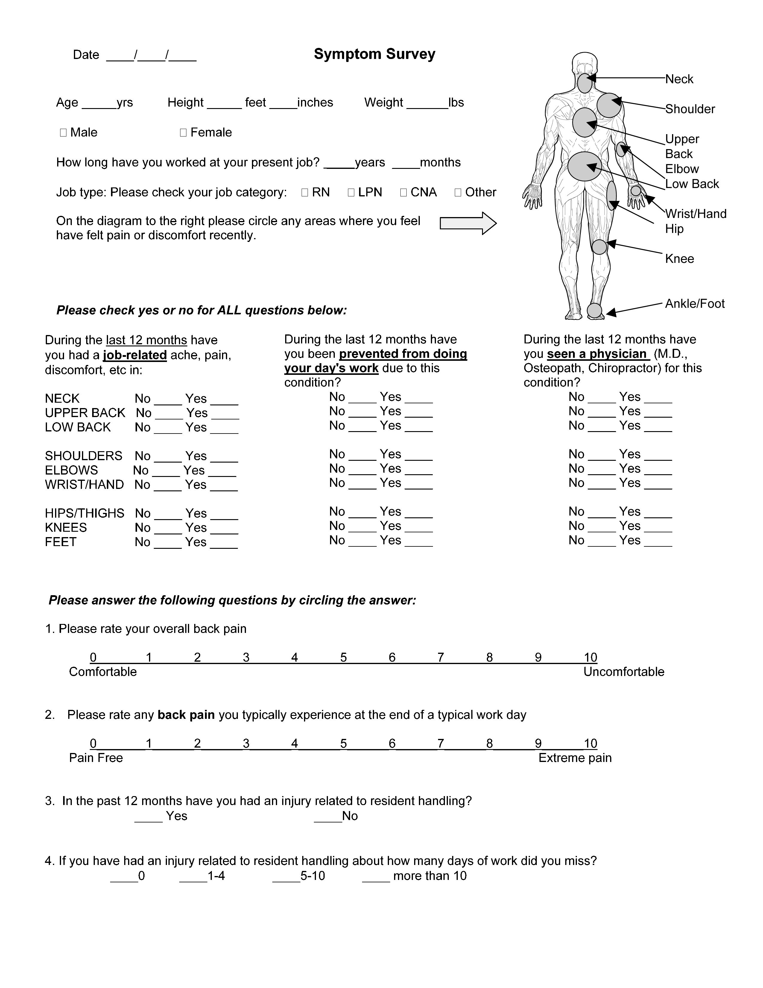

Resident Satisfaction Survey

Instructions: The person administering the survey should answer the first 4 questions:

1) What is the resident’s dependency level? _________________________________ (use the criteria below)

- Independent— Resident performs task safely, with or without staff assistance or assistive devices.

- Partial Assist—Resident requires no more help than stand-by, cueing, or coaxing, or caregiver is required to lift no more than 35 lbs. of a resident’s weight.

- Dependent—Resident requires nurse to lift more than 35 lbs. of the resident’s weight, or is unpredictable in the amount of assistance offered.

2) Does a caregiver usually assist this resident with moving from a bed, chair, wheelchair or toilet, to another surface, or ambulation? YES NO IF NO, STOP HERE

3) Is the resident usually lifted, moved or ambulated manually or using equipment? Manually Equipment

4) What type of assistance is most frequently provided (circle all that apply):

a) Transfer from one surface to another
b) Reposition in bed
c) Assistance with ambulation
d) Other – please specify: __________________________________________________________

Instructions: Explain to the resident “These questions refer to assistance you have received being lifted or moved from one surface to another, such as when you receive help moving from your bed to a chair or a wheelchair, or to the toilet or shower, or when you receive help walking.” Explain that you are asking about assistance they have received in the last 2-3 weeks.

Please CIRCLE the response that best reflects the resident’s view about being lifted or transferred in the last 2-3 weeks, as you ask them each question.
1. How comfortable do you feel when caregivers provide assistance being lifted, moved, or with walking? | Very Uncomfortable | Somewhat Comfortable | Somewhat Uncomfortable | Very Comfortable
2. How safe do you feel being lifted, moved or with assistance walking? | Very Unsafe | Somewhat Safe | Somewhat Unsafe | Very Safe
3. Do you fear being injured, dropped or falling when being lifted, moved or with walking assistance? | Always | Most times | Not Usually | Never
4. Do you ever get abrasions or bruises from being lifted or moved? | Always | Most times | Not usually | Never
5. How satisfied are you with the methods used to lift or move you or with walking assistance? | Very Satisfied | Somewhat Satisfied | Somewhat Unsatisfied | Very Unsatisfied
6. How would you rate your overall care when being lifted or moved by caregivers, or with walking assistance? | Excellent | Satisfactory | Unsatisfactory | Poor

Family Satisfaction Survey

Instructions: The person administering the survey should answer the first 4 questions. Then ask a family member to complete the 6 questions in the boxes below.:

1) What is the resident’s dependency level? _________________________________ (use the criteria below)

- Independent— Resident performs task safely, with or without staff assistance or assistive devices.

- Partial Assist—Resident requires no more help than stand-by, cueing, or coaxing, or caregiver is required to lift no more than 35 lbs. of a resident’s weight.

- Dependent—Resident requires nurse to lift more than 35 lbs. of the resident’s weight, or is unpredictable in the amount of assistance offered.

2) Does a caregiver usually assist this resident with moving from a bed, chair, wheelchair or toilet, to another surface, or ambulation? YES NO IF NO, STOP HERE

3) Is the resident usually lifted, moved or ambulated manually or using equipment? Manually Equipment

4) What type of assistance is most frequently provided (circle all that apply):

a) Transfer from one surface to another
b) Reposition in bed
c) Assistance with ambulation
d) Other – please specify: __________________________________________________________

Instructions: Ask a family member to answer the questions below. Explain to the family member “These questions refer to assistance provided to your family member (mother, father, sister, etc) when being lifted or moved from one surface to another, such as when you receive help moving from your bed to a chair or a wheelchair, or to the toilet or shower, or when you receive help walking.” Explain that you are asking about assistance the family member has received in the last 2-3 weeks.

Please CIRCLE the response that best reflects the family member’s view about the resident being lifted or transferred in the last 2-3 weeks.
1. How comfortable is your family member when caregivers provide assistance being lifted, moved, or with walking? | Very Uncomfortable | Somewhat Comfortable | Somewhat Uncomfortable | Very Comfortable
2. How safe do you feel your family member is when being lifted, moved or with receiving assistance walking? | Very Unsafe | Somewhat Safe | Somewhat Unsafe | Very Safe
3. Do you fear your family member will be injured, dropped or fall will when being lifted, moved or with walking assistance? | Always | Most times | Not Usually | Never
4. Does your family member ever get abrasions or bruises from being lifted or moved? | Always | Most times | Not usually | Never
5. How satisfied are you with the methods used to lift or move your family member, or with walking assistance? | Very Satisfied | Somewhat Satisfied | Somewhat Unsatisfied | Very Unsatisfied
6. How would you rate your overall care when your family member is lifted or moved by caregivers, or with walking assistance? | Excellent | Satisfactory | Unsatisfactory | Poor

Safe Resident Handling Worker Input Questionnaire

(Only provide your name if you would like someone to follow-up with you)

This questionnaire is intended to take -5- minutes or less to complete

- What tools and equipment that you currently use best assist you in performing your job? What equipment is not effective?

- How much time (average) is usually necessary to transfer a resident and do you typically feel safe for yourself and the resident during transfers?

- Explain how responsive other teammates are when asked to assist with resident care? Are they available immediately? If not how long does it usually take (minutes)?

- What do you think would improve current safety trainings for new and veteran staff?

- Please feel free to write down any other safety ideas, concerns, and/or anything that you feel should be taken into consideration for the Safe Resident Handling Program.

Please remember this questionnaire is used as a guide to help assist this facility to make this program successful. All input is welcome and appreciated.

Principles of Safe Resident Handling Class
Evaluation Form

Please circle the best answer and write comments below

1. How would you rate this class? Excellent Good OK Poor

2. Were the teaching methods effective? Yes No Don’t know

3. Were power point slides easy to see and understand? Yes No Don’t know

4. Was there sufficient time for discussion? Yes No Don’t know

5. Will the information be useful for developing Yes No Don’t know
a safe resident handling program?

6. What would have made this class more useful or better, and other comments?

- List 3 key elements of a SRH program

- Name 2 reasons why manual resident handling is dangerous

- List 3 reasons why SRH programs fail

- List the 4 main steps to implementing a SRH program
Safe Resident Handling for Administrators: Making the Business Case Class Evaluation Form

Please circle the best answer and write comments below

1. How would you rate this class? Excellent Good OK Poor

2. Were the teaching methods effective? Yes No Don’t know

3. Were power point slides easy to see and understand? Yes No Don’t know

4. Was there sufficient time for discussion? Yes No Don’t know

5. Will the information be useful for developing Yes No Don’t know
a safe resident handling program?

- What would have made this class more useful or better, and other comments?

- List 3 key elements of a SRH program

- Name 2 reasons why manual resident handling is dangerous

- List 3 reasons why SRH programs fail

- List 2 methods or measures business should use to evaluate the economic cost of implementing a Safe Resident Handling Program

Tool for Prioritizing High-Risk Resident Handling Tasks
Directions: Assign a rank (from 1 to 10) to the tasks you consider to be the highest risk tasks contributing to musculoskeletal injuries for persons providing direct resident care. A “1” should represent the highest risk, “2” the second highest, etc. For each task consider the frequency of the task (high, moderate, low) and the musculoskeletal stress (high, moderate, low) Should be completed by one RN and CNA per shift.
SRH Team Member: | RN/ CNA | Shift: Day Night Swing |  | Wing:
Resident Handling Tasks | Frequency  of Task  H=high  M=Moderate  L=Low | Stress  of Task  H=high  M=ModerateL=Low | Risk  of Task  1= high  10 = Low Risk | How many times task performed per Shift (approx.)
- Transferring Resident to/from wheelchair or shower/commode or Geri chair to bed
- Transferring Resident to/from wheelchair or chair to toilet
- Transferring Resident to/from bathtub to chair
- Transferring Resident to/from car
- Transferring a Resident to/from bed to stretcher or gurney
- Repositioning Resident in bed from side to side
- Repositioning Resident to the head of the bed
- Repositioning Resident in geriatric chair or wheelchair
- Bathing a Resident in bed
- Ambulation from bed or chair
- Weighing a Resident
- Lifting a Resident up from the floor
- Transporting Resident off unit
- Undressing/dressing a Resident
- Applying anti-embolism stockings
- Positioning Resident on a bed pan
- Holding or supporting the weight of a limb during medical or nursing procedures
- Making an occupied bed
- Feeding bed-ridden Resident
- Changing absorbent pad
- Other Resident Handling Task:
- Other Resident Handling Task:
Sources: VA, 2005, Lynda Enos, MS, RN, CPE, 2005

Unit Profile and Space/Maintenance/Storage Evaluation
1. | Directions: Describe Unit/wing, including # beds, room configurations (private, semi-private, 4-bed, etc), and bathrooms:
# rooms private (1 bed) _____ # rooms with 2 beds ____ Other: _____

Bathrooms: In room?_____ Community _____ Use tub? _____ Shower chair? _____
Other: _____

Draw room configuration (on back as needed)
2. | Describe current storage conditions and problems you have with storage. If new equipment is purchased, where would it be stored?
3. | Identify anticipated changes in the physical layout of your unit, such as planned unit renovations in the next 2 years
4. | Describe space constraints for resident care tasks & use of portable equipment; focus on resident rooms, bathrooms, and shower/bathing areas. Are typical room doorways narrow or wide?? Is the threshold uneven?
5. | Describe any routine equipment maintenance program or process for fixing broken equipment. What is the reporting mechanism/procedure for identifying, marking, and getting broken equipment to shop for repair?
6. | If potential for installation of overhead lifting equipment exists, describe any structural factors that may influence this installation, such as structural load limits, lighting fixtures, protruding sprinkler heads, other ceiling fixtures, AC vents, presence of asbestos, etc.
Sources: VA, 2005, Lynda Enos, MS, RN, CPE, 2005

Administrative Checklist
Directions: Based on observations in the unit/wing identify areas that may need a closer look
FACTOR | Needs a Closer Look |  | COMMENTS
FACTOR | NO | YES | COMMENTS
- Systematic resident assessment
- Formal policy or criteria for:
  - Getting help or using assist devices
  - Early reporting of problems
  - Guiding instead of stopping falls
- Equipment maintenance:
  - Standardized tags
  - Short turnaround time-most of time
  - Effective tracking systems
- Equipment purchasing/distribution:
  - Flexible contracts
  - Systematic end-user reviews
  - Sufficient quantities ordered
  - Adequate storage
- Communication with employees by:
  - Meetings (staff)
  - Bulletin boards or memos
  - In-service or training sessions
  - Other means (please specify)
- Job expectations clearly communicated

- Training:
  - All employees trained
  - Hands-on practice
  - Opportunity for feedback
  - Content is comprehensive (e.g., equipment, policies, etc.)
  - Demonstrated in competency –Systematically reinforced
  - Other (please specify)
- Where possible, physically hard work tasks distributed equally among employees or shifts
- Where possible, scheduling avoids employees performing unaccustomed physical work
- Other (e.g., effective early reporting)
Sources: VA, 2005, Lynda Enos, MS, RN, CPE, 2005

Facilities Design Checklist
Directions: Place a check mark in the space next to each item you feel may be a problem area in your dept/unit.
FACTOR | PROBLEM | LOCATION
- High threshold or obstructions in entry ways of bathrooms, showers, hallways, etc. prevent access for assist equipment
- Steep ramp (greater than 10 degrees)
- Small or cluttered rooms/bathrooms/
hallways or other spaces
- Door handles catch on beds/gurneys/etc.
- Floors slippery/uneven/cluttered
- Storage areas too high/low/awkward to reach
- Bedside medical and electrical outlets too low/only on one side
- Inadequate storage space
- No grab rails by toilets or in bathtubs or showers
- Toilet seats too low
- Other

Adapted from Lynda Enos, MS, RN, CPE, 2005

Equipment Use Inventory
Directions: Answer the following questions related to equipment handling/transport in your department or that you may have access to through another department.
Department: |  | Employee Name: |  |  |  |  | RN/CNA |  | Shift: Day Night Swing
Resident Handling Device | Do you have this equipment in your dept?  Y or N  If Y – what’s the name or brand of equipment, e.g. ‘Omega lift, Hovermat, etc) | If Yes  How many on unit? | What is the weight limit of the equipment if applicable? | How often do you use it?  4= all of the time  3=most of the time  2=sometimes  1=rarely or never |  |  | Is this equipment in good working order?  Y or N  Comment: |  | If used rarely or never why? | Other Comments
- Powered Floor Lift (Battery/electric power)
- Ceiling Lift
- Powered Sit to Stand Lift
- Air Mat for lateral supine transfers, e.g. Hovermat
- Roller mat
- Other types of Transfer mats or boards

White Slide board (supine position)
- Slippery sheets for repositioning
Developed by Lynda Enos, MS, RN, CPE, 2005
- Gait or transfer belt Please note if with handles
- Low-friction mattress covers
- Shower cart or gurney
- Shower or toilet chair (commode)
- Geri chair
- Wheel chair
- Other chairs that Residents use
- Adjustable height beds-List each make and model
- Other:
- Other:
Other equipment: | Please also note any specific issues or problems with this type of equipment
- Carts - Medicine
- Carts - Laundry
- Carts - Food
- Carts – Other - Describe
- Gurneys/Stretchers
List each make and model and if height adjustable

- IV /Med poles
- Other medical equipment

Ergonomic Observational Assessment

Identifying Risk Factors, Determining Root Causes & Possible Solutions

1. Date _____________________ 2. Observer: _________________

3. Dept/Unit____________________________

4. Shift Evaluated: Day Swing Night

5. Definition of resident’s level of assistance for lifts and transfers (from VA):

- Independent— Resident performs task safely, with or without staff assistance or assistive devices.

- Partial Assist—Resident requires no more help than stand-by, cueing, or coaxing, or caregiver is required to lift no more than 35 lbs. of a resident’s weight.

- Dependent—Resident requires nurse to lift more than 35 lbs. of the resident’s weight, or is unpredictable in the amount of assistance offered.

6. What factors contribute to making the task high risk?

- Task/Process – lack of appropriate equipment
- Facility Design – too little or poor room or work space
- Work Practices – adjustments on equipment not made, equipment no used

Additional information to gather if feasible:

7. How many times per shift is task performed?

8. Does staff report specific tasks that are difficult to perform – if so note task type and staff comments.

NOTES
Ergonomics Assessment Instructions

For each task list, the contributing factor(s) you observe and the reasons for the risk.
- Awkward postures – prolonged reaching, twisting, bending, working overhead, kneeling, squatting, holding fixed position, or pinch grips
- Repetition – Performing the same types of motions over and over using the same parts of the body
- Forceful exertion – The amount of muscular effort used to perform work
- Pressure points (local contact stress) – The body pressing against hard or sharp surfaces
- Vibration – Continuous or high-intensity hand–arm or whole-body vibration
- Other factors – Extreme high or low temperatures; lighting too dark or too bright

Potential Risk Factors  and Body Region | Root Causes of Risk Factor Observed (Reason) | Possible Solution(s)
Job Task: Date:
EXAMPLE: Moving dirty linen bags
Repetitive Forward bend of torso >60 degrees coupled with twisting and side bending of back | Lifting bags from floor.  Dirty linen bags weighed an average of 20lbs | Soiled linen cart design – too high  Consider using different cart that allows for access to linen chutes, improved visibility and has dropped away panels for improved access when loading bags.  Consider carts for garbage and soiled laundry with spring load bases that reduce reach and force required to load and unload bags.
Task: ___________________
Task: ___________________
Task: ___________________

High Hazard Activities and Risk Factors
Source: WISHA Ergonomics Rule: HAZARD ZONE CHECKLIST (APPENDIX B) - WAC 296-62-05174
Awkward Postures – exposure for more than 4 hours per shift |  | High Hand Force – exposure for more than 4 hours per shift
- Hands above head  - Elbow above shoulder | 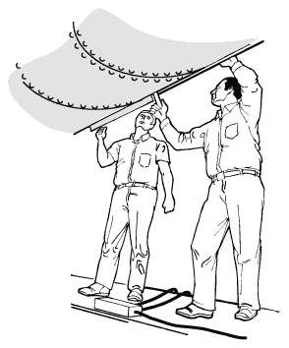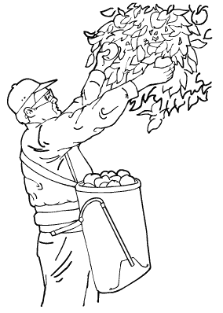 | Pinching an unsupported object(s) weighing 2 lbs or more per hand, or pinching with a force of 4 lbs or more per hand (comparable to pinching a half a ream of paper) | 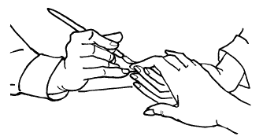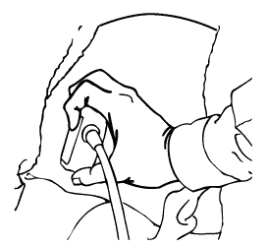
- Back bent forward more than 45 degrees  - Neck bent more than 45 degrees | 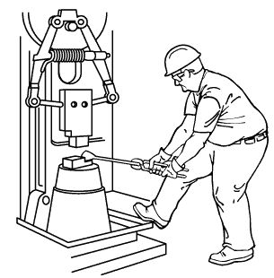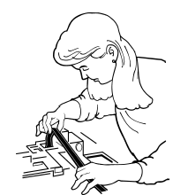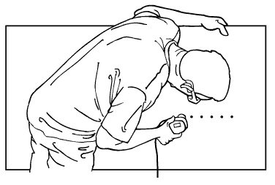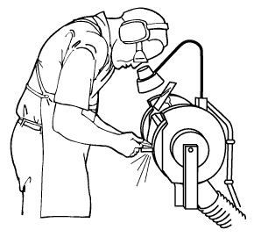 | Gripping an unsupported object(s) weighing 10 lbs or more per hand, or gripping with a force of 10 lbs or more per hand (comparable to clamping light duty automotive jumper cables onto a battery)  Duration of exposure =3 hours per shift if repetitions and or awkward postures are also used | 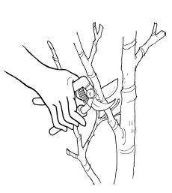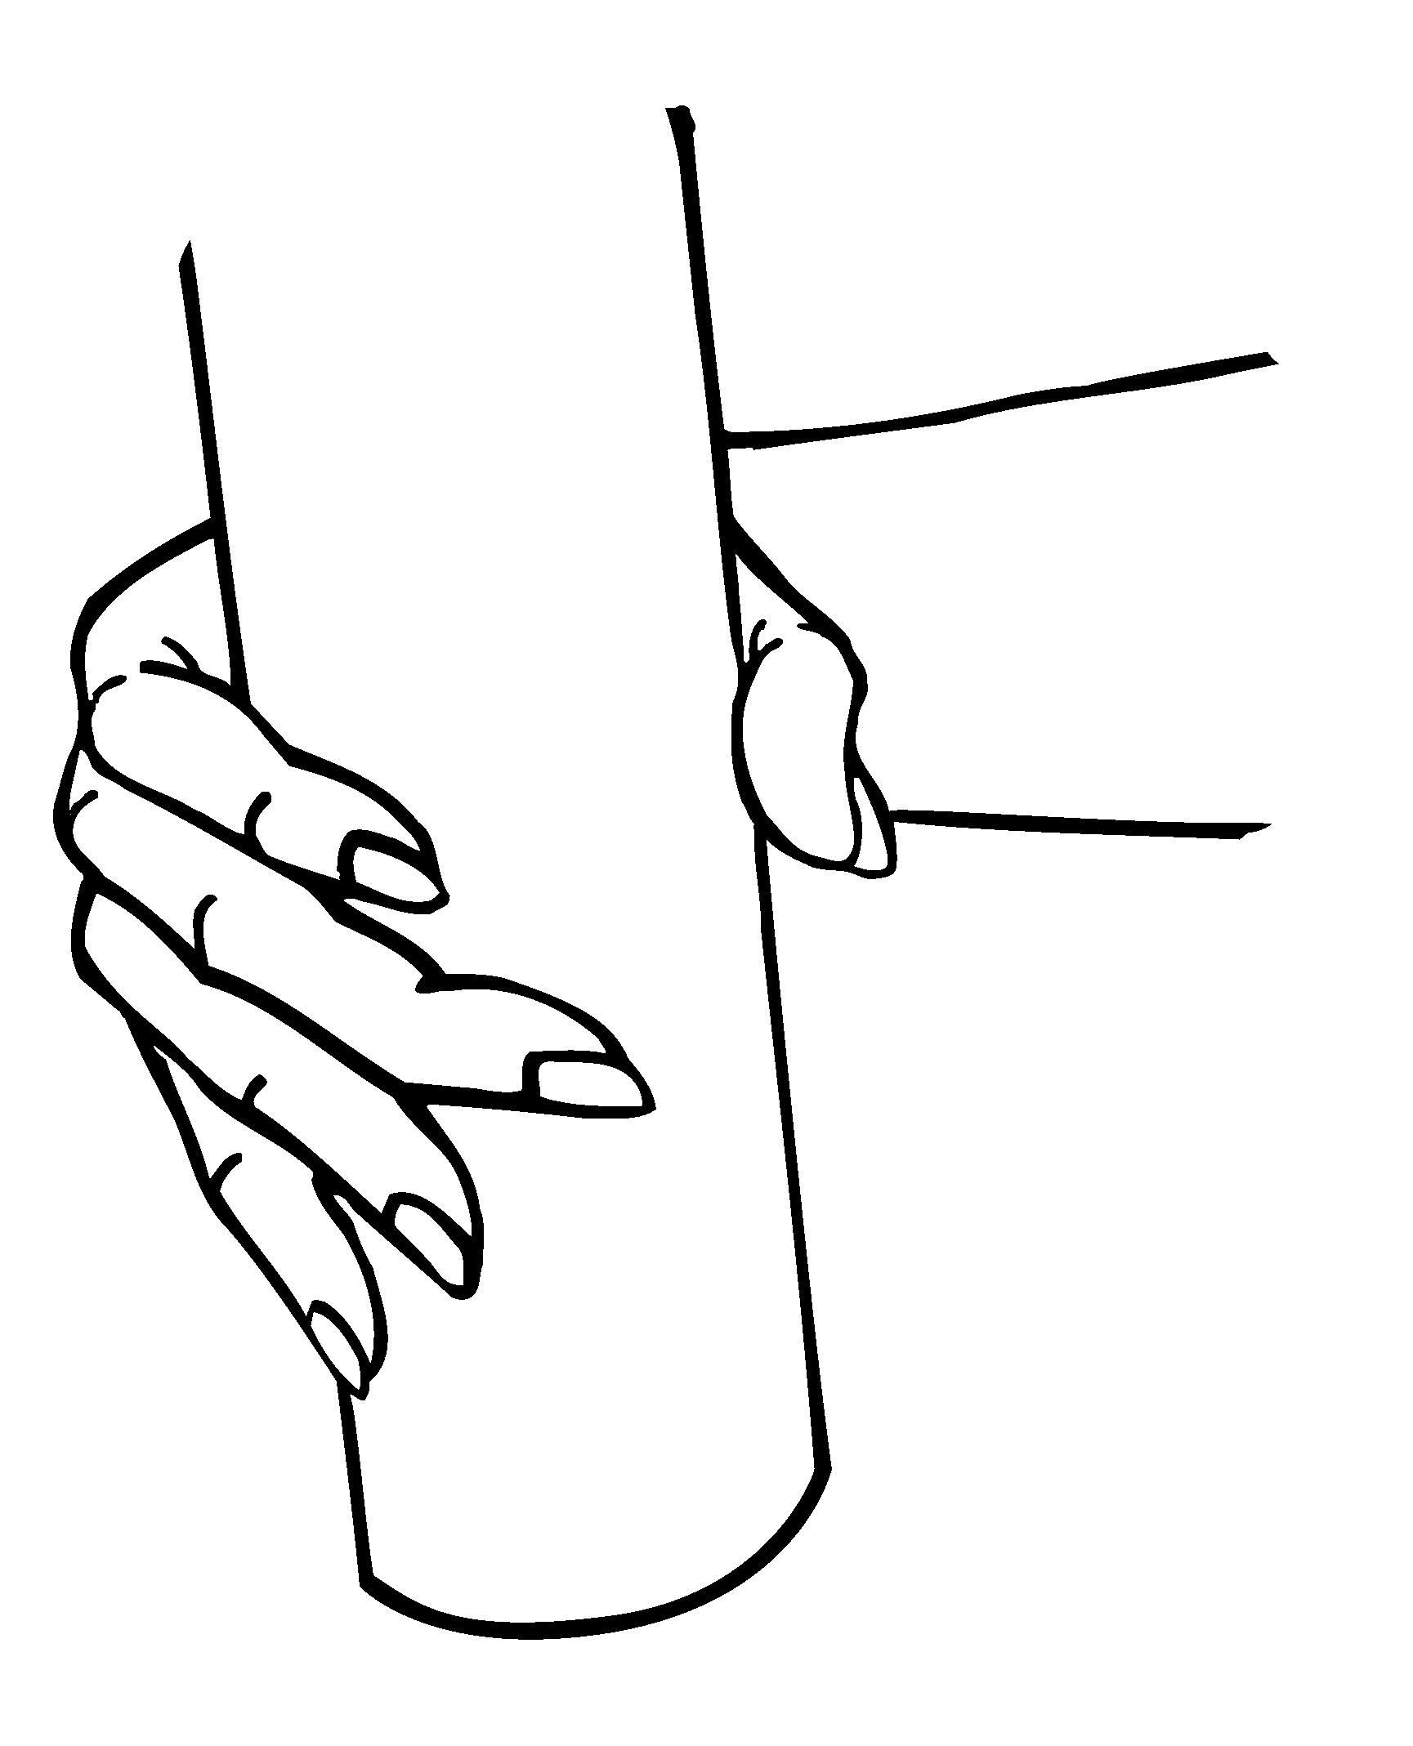
- Squatting  - Kneeling | 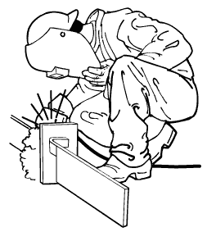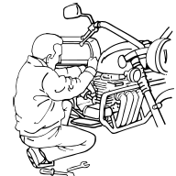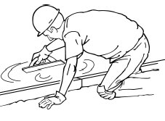 | Highly Repetitive Motion - exposure for more than 6 hours per shift  Duration of exposure = 2 hours per shift if repetitions and awkward postures are also used  Intensive keyboarding –Duration of exposure = 4 hours per shift if repetitions and awkward postures are also used | 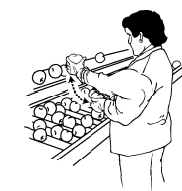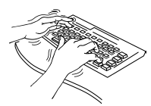  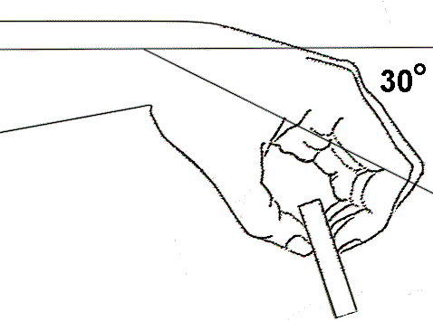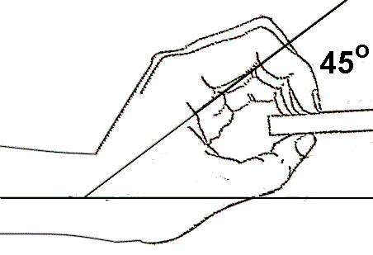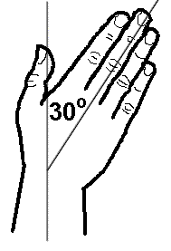
Repeated Impact - exposure for more than 2 hours per shift  - Using hands or knees as a hammer more than once per minute | 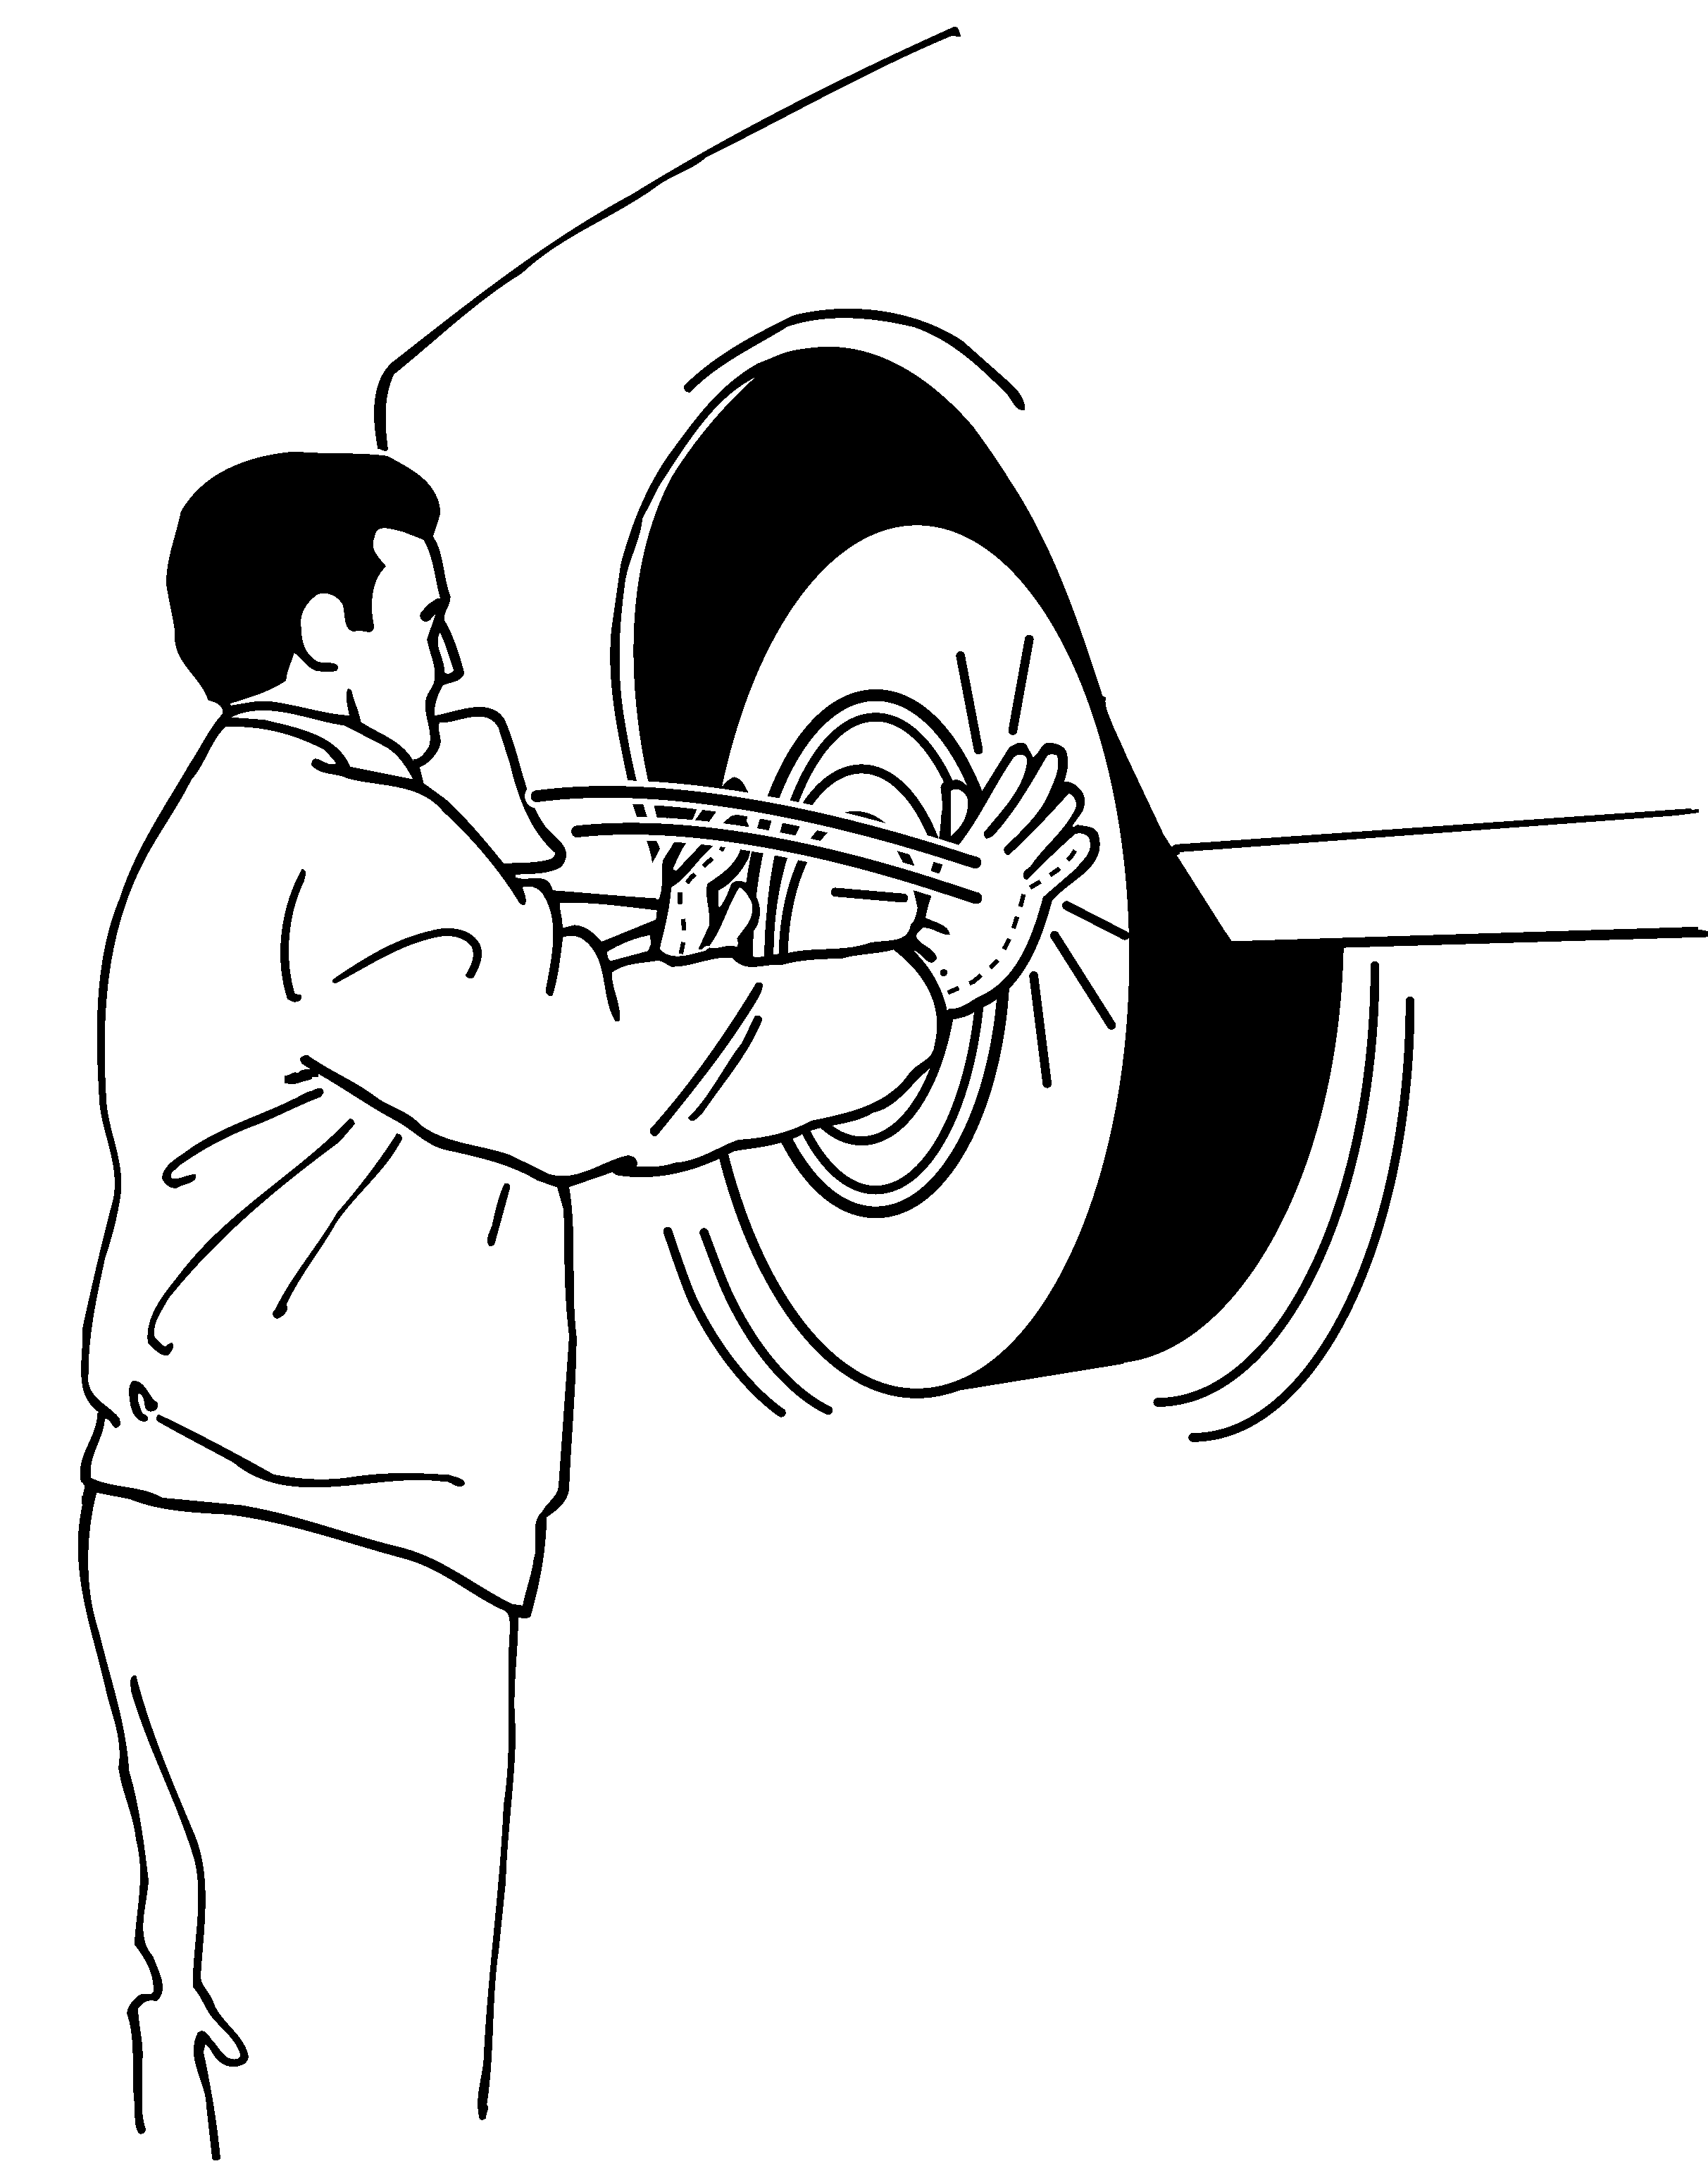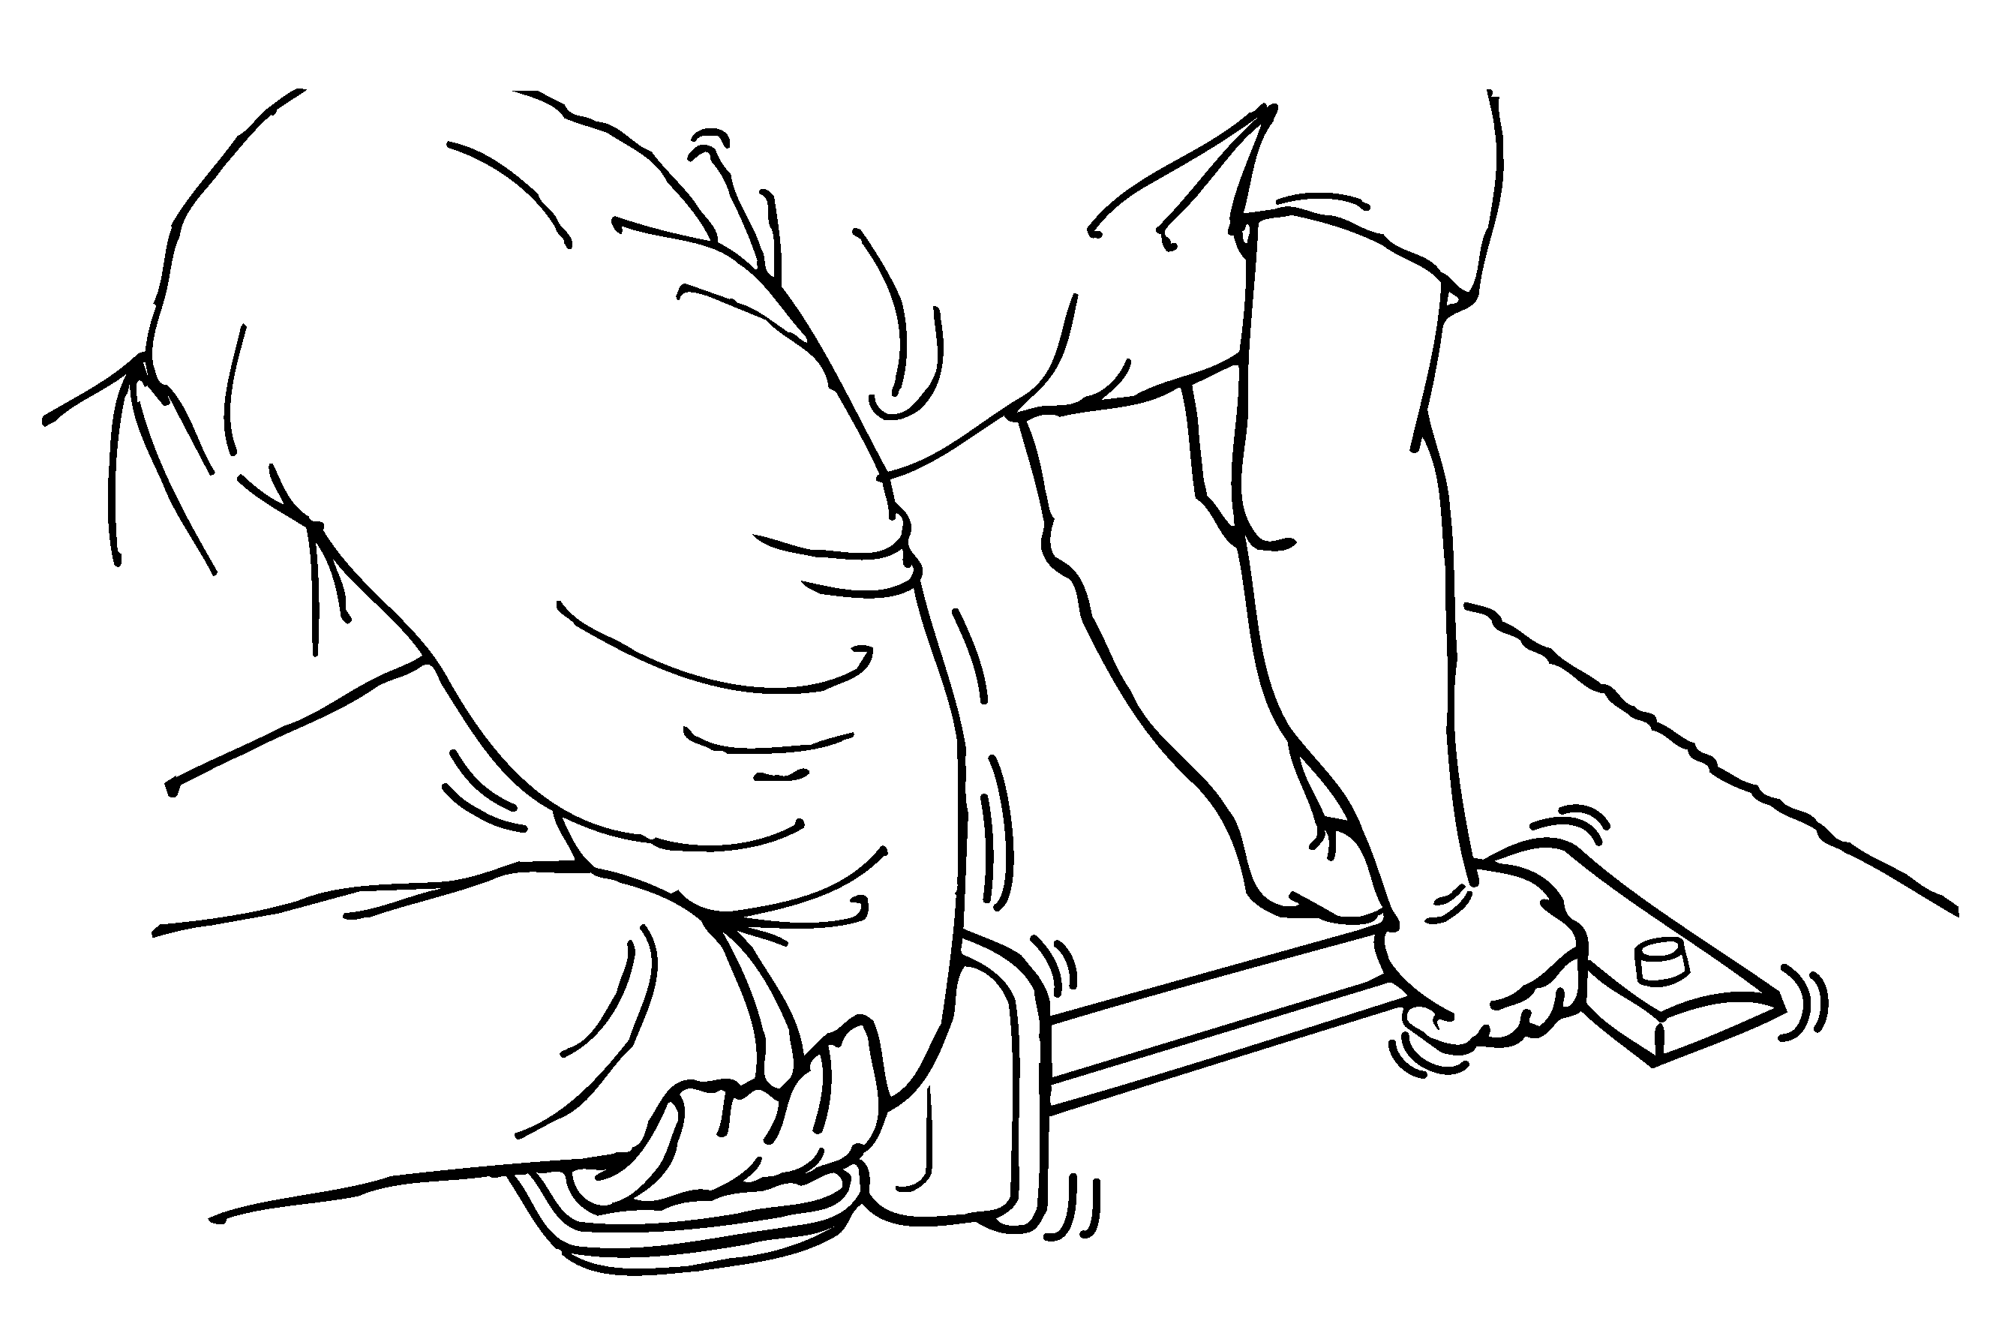 | Moderate to High Hand-Arm Vibration  Refer for evaluation of frequency and exposure | 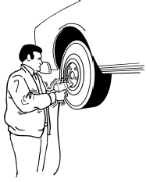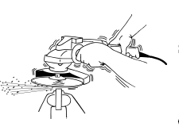
Heavy, Frequent or Awkward Lifting, Pushing, Pulling, Carrying
- 75 lbs. once/day  - 55 lbs. more than ten times/day | 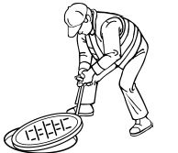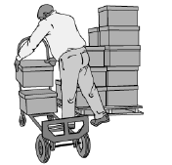 | 25 lbs. above shoulders, below knees, or at arms length for more than 25 times/day  10 lbs. more than twice/minute for more than 2 hours per day | 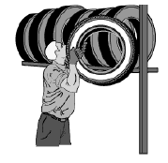
- Manually pushing or  - pulling objects or equipment over 50 lbs | 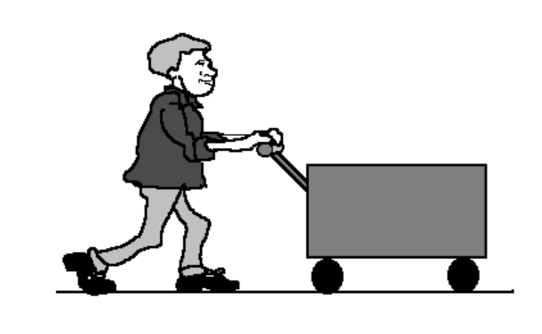

Safe Resident Handling Ergonomics Class Evaluation Form

Please circle the best answer and write comments below

1. How would you rate this class? Excellent Good OK Poor

2. Were the teaching methods effective? Yes No Don’t know

3. Were power point slides easy to see and understand? Yes No Don’t know

4. Was there sufficient time for discussion? Yes No Don’t know

5. Will the information be useful for developing Yes No Don’t know
a safe resident handling program?

- What would have made this class more useful or better, and other comments?

- List 4 risk factors for musculoskeletal injury

- Identify the most and least effect solutions to prevent injuries

- List the 4 steps to conducting a risk assessment

Summary of Resident Handling Needs and Risk
Promote a Culture of Safe & Compassionate Resident Handling while Enhancing Caregiver and Resident Safety

Ergonomics observation and quantification of risk factors were conducted representing frequently performed resident handling tasks. Review of facility design, resident ‘type’ and perceived risk of injury by staff conducted in a representative sample of resident rooms
Resident Handling Tasks  ___ % Residents  Total Dependent or Extensive Assist | Resident Handling Tasks  Perceived Injury Risk  1=High  10+ Low | Perceived Physical Stress | Task Frequency  H-high  M-med  L-low | Existing Equipment/  Staff Comments | Risk Factors Observed (to caregiver) | Root Cause  Of Risk Factors | Possible Solutions -Work Practice/ Procedures  Common to all tasks: Resident assessment; prep room; use of bed adjustments | Possible Solutions -Engineering  Resident dependency level considered  All residents assessed for handling and transfer needs on admission
1. Seated transfers: Transferring Resident to/from wheelchair or chair | 10 | M | H, 10 times/shift | Older powered Hoyer – 350lbs capacity –limited weight capacity | Trunk flexion over 45 degrees  Side bending and rotation  Abduction of arms  Forceful motion – can be sudden and nurse/aide supports 75%+ of resident’s body weight | Height of bed and/or chair influences angle of trunk flexion  Resident status re weight bearing capability  /dependency level | Prep of room – clear of clutter and placement of chair  Resident assessment for suitability to bear weight | Dependent Residents:  - Ceiling lift  - Floor lift with scale  Semi –Dependent (UE coordination/some weight bearing/cooperative):  - Sit to Stand assist – powered or non-powered  Supervised/Independent  - Gait belt with handles.
Developed by Lynda Enos, MS, RN, CPE, 2008

Resident Handling Tasks  ___ % Residents  Total Dependent or Extensive Assist | Resident Handling Tasks  Perceived Injury Risk  1=High  10+ Low | Perceived Physical Stress | Task Frequency | Existing Equipment/  Staff Comments | Risk Factors Observed  (to caregiver) | Root Cause  Of Risk Factors | Possible Solutions -Work Practice/ Procedures  Common to all tasks: Resident assessment; prep room; use of bed adjustments | Possible Solutions -Engineering  Resident dependency level considered  All residents assessed handling and transfer needs on admission

Equipment Day Sign-up Sheet Date: ____________

# | Name | Job Title | Shift | Time out | Time out
1
2
3
4
5
6
7
8
9
10
11
12
13
14
15
16
17
18
19
20
21
22
23
24
25
26
27
28
29
30
31
32
33
34
35
36
37
38

Technology Solutions for Safe Patient Handling and Movement Department of Veterans Affairs

Attachment 4-1
Product Feature Rating Survey (Caregiver)

Caregiver #: _________ Product #: _________________ Date: ________

Please examine the product very carefully and answer the following questions as they relate to this product ONLY. Please answer each question using a scale from 0 to 10, by circling the number that matches your impression, where 0 indicates a very poor design and 10 indicates a very well designed feature.

We encourage you to express any ideas you may have for improving the product design. Please make your comments alongside the appropriate feature rating.

1. How would you rate your OVERALL COMFORT while using this product?

Very 0 1 2 3 4 5 6 7 8 9 10 Very
Poor Good

2. What is your impression of this product’s OVERALL EASE-OF-USE?

Very 0 1 2 3 4 5 6 7 8 9 10 Very
Poor Good

3. How EFFECTIVE do you think this product will be in reducing INJURIES?

Very 0 1 2 3 4 5 6 7 8 9 10 Very
Poor Good

4. How EFFICIENT do you feel this product will be in use of your TIME?

Very 0 1 2 3 4 5 6 7 8 9 10 Very
Poor Good

5. How SAFE do you feel this product would be for the PATIENT?

Very 0 1 2 3 4 5 6 7 8 9 10 Very
Poor Good

Technology Solutions for Safe Patient Handling and Movement Department of Veterans Affairs

Attachment 4-2
Product Ranking Survey (Caregiver)

Caregiver #: ___________________ Date: ___________

Finally, look at each of the five products you have just used. We would like you to rank each of these products, in order of preference. Placing the letter assigned to each produce (A-E) alongside the rank order which you feel is most appropriate, where 1 is your most preferred design, and 5 is your least preferred design. Note any comments you may have in the space provided. [Note this form can be revised if more or less than 5 products are being evaluated.]

Overall Comfort: 1: ________ 2: ________ 3: ________ 4: _______ 5: _________

Comments:
________________________________________________________________________________________________________________________________________________________________________

Ease-of-Use: 1: ________ 2: ________ 3: ________ 4: _______ 5:________

Comments:
________________________________________________________________________________________________________________________________________________________________________

Stability: 1: ________ 2: ________ 3: ________ 4: _______ 5:_________

Comments:
________________________________________________________________________________________________________________________________________________________________________

Durability: 1: ________ 2: ________ 3: ________ 4: _______ 5: _________

Comments:
________________________________________________________________________________________________________________________________________________________________________

Versatility: 1: ________ 2: ________ 3: ________ 4: _______ 5: _________

Comments:
_____________________________________________________________________
EQUIPMENT PURCHASING CONSIDERATIONS

While the acquisition of patient handling equipment is an integral part of any Safe Patient Handling Program, a thorough and careful assessment of the patient population and the needs of the population should be done prior to any purchasing. Once the equipment needs have been determined the next step is to decide which equipment best suits the needs of the hospital’s and which vendor to purchase the equipment from. Key issues should be considered vendor prior to making any purchases. The following is a list of these key issues.

GENERAL VENDOR INFORMATION

- How long has the company been in business in your state?
- How long has the representative worked with them?
- How many clients do you service in the state?
- How many customer service representatives do you have?

VENDOR CUSTOMER SERVICE

- What is your average onsite response time for service/
- Will the company replace equipment if it is not functioning correctly?
- If so, what is the turn-around time? ______________________________
- Does the vendor have a set of service standards?
- What is your response time to resolve a customer problem?
- Does the company do problem solving follow-up if the equipment is not functional?
- Does the vendor have state representatives that can arrive and problem solve within a short
period of time?
- Can the company provide data on the success of using their equipment?
- How fast are replacement parts shipped?

VENDOR PROVIDED TRAINING

- Does the vendor provide training for all shifts?
- Will the vendor return and train new staff periodically?
- Does the training include the use of all types of slings available for the equipment? i.e. walking
slings, disposable slings, supine slings, octopus, custom-made for amputees?
- Will the vendor provide orientation and training for doctors
- Does the vendor have training videos?
Adapted from Washington Labor and Industries, 2008

EQUIPMENT PRODUCT SUPPORT

- What is the vendor’s equipment evaluation period (trial period)?
- What is the warranty on the equipment?
- Has the equipment been evaluated in a published study?
- Will the vendor help the hospital in assessing and matching patient types with
equipment?

EQUIPMENT FUNCTIONALITY

- Does the equipment have features that are not available in other products?
- If so, what are they? ________________________________________
- What other hospitals in Washington have this device? Can they be contacted for
questions?
- What is the lift expectance of the equipment?
- What are the storage requirements for the equipment?
- How does this equipment fit into our hospital?
- Can the device fit into our bathroom?
- Will the device fit at the bedside?
- Will the equipment lift a patient from a car?
- Who is responsible for charging or changing the batteries
- Will the equipment fit under beds? Under X-ray tables?
- Is the equipment able to pass through all doors in the facility?
- Does the equipment fit into elevators?
- Does the equipment have an emergency shut-off switch
- Can the healthcare worker maintain proper body mechanics while operating the
equipment?
- Is the capacity and operations instructions listed on the equipment?

INFECTION CONTROL

- What are the infection control procedures?
- Are disposable slings available?
- Does the hospital’s internal infection control staff approve of the process for
infection control?

Adapted from Washington Labor and Industries, 2008

MAINTENANCE

MAINTENANCE

- How long does battery charge last?
- What maintenance is required by the hospital?
- What maintenance is required by the vendor?
- Who is responsible for upgrades and recalls?
- What is the lifespan of the battery?
- What is the procedure for replacing defective parts?
- How fast are replacement parts shipped?
- What are the limitations of the warranty?

BARIATRIC

- Does the vendor offer bariatric equipment?
- Is it for sale or for rent?

SLINGS

- How are the slings used?
- How often do slings need to be replaced?
- Is it possible for the patient/resident to slip out of the sling?
- Are the slings interchangeable within a product line? i.e. from ceiling lift to total lift
to sit/stand lifts

CEILING LIFTS

- Is it possible to move ceiling lifts after they have been installed?
- What configurations of ceiling lifts are available? Single track or traverse?
- What are the structural requirements for each?
- Where will the ceiling lifts be used? Function and use of ceiling lifts depend upon
place in the facility it will be used.
Adapted from Washington Labor and Industries, 2008

Template of a Safe Resident Handling and Movement Policy

(Adapted from Veterans Affairs, Resident Care Ergonomics Resource Guide: Safe Resident Handling and Movement, http://www.visn8.med.va.gov/residentsafetycenter/safePtHandling/default.asp)

1. PURPOSE: This policy describes ways to ensure that employees use safe resident handling and movement techniques at _________________ (facility) for safe resident handling and movement.

2. POLICY: __________________________(facility) wants to ensure that its residents are cared for safely, while maintaining a safe work environment for employees. To accomplish this, direct care staff on high risk resident care areas should assess high risk resident handling tasks in advance to determine the safest way to accomplish them. Additionally, mechanical lifting equipment and/or other approved resident handling aids should be used to prevent the lifting and handling of residents/residents except when absolutely necessary, such as in a medical emergency.

3. PROCEDURES:

A. Compliance: It is the duty of employees to take reasonable care of their own health and safety, as well as that of their co-workers and their residents during resident handling activities by following this policy. Non-compliance will indicate a need for retraining.

B. Resident Handling and Movement Requirements:
- Avoid hazardous resident handling and movement tasks whenever possible. If unavoidable, assess them carefully prior to completion.

- Use mechanical lifting devices and other approved resident handling aids for high-risk resident handling and movement tasks except when absolutely necessary, such as in a medical emergency.

- Use mechanical lifting devices and other approved resident handling aids in accordance with instructions and training

C. Training:
- Staff will complete and document training initially, annually, and as required to correct improper use/understanding of safe resident handling and movement. Supervisors should maintain training records for three (3) years.

D. Mechanical lifting devices and other equipment/aids:
- Supervisors will ensure that mechanical lifting devices and other equipment/aids are accessible to staff.

- Supervisors shall ensure that mechanical lifting devices and other equipment/aids are maintained regularly and kept in proper working order.

- Supervisors and staff shall ensure that mechanical lifting devices and other equipment/aids are stored conveniently and safely.

E. Safe Resident Handling and Movement Research Program
- Care giving staff will collaborate with Safe Resident Handling and Movement Program staff in evaluating the Safe Resident Handling and Movement Policy.

F. Reporting of Injuries/Incidents:
- Care giving staff shall report to Occupational Health all strain/sprain incidents/injuries resulting from resident handling and movement.

- Supervisors shall maintain Accident Reports and supplemental injury statistics as required by the facility and requested by Safe Resident Handling and Movement Research Project staff.

4. DEFINITIONS:

A. High Risk Resident Handling Tasks: Resident handling tasks that have a high risk of musculoskeletal injury for staff performing the tasks. These include but are not limited to transferring tasks, lifting tasks, repositioning tasks, bathing residents in bed, making occupied beds, dressing residents, turning residents in bed, and tasks with long durations.

B. High Risk Resident/Resident Care Areas: In resident wings with a high proportion of dependent residents, requiring full assistance with resident handling tasks and activities of daily living. Based on the dependency level of residents and the frequency with which residents are encouraged to be out of bed. These areas include Spinal Cord Injury Units, Nursing Home Care Units, and other specified areas.

C. Manual Lifting: Lifting, transferring, repositioning, and moving residents using a caregiver’s body strength without the use of lifting equipment/aids to reduce forces on the worker’s musculoskeletal structure.

D. Mechanical Resident Lifting Equipment: Equipment used to lift, transfer, reposition, and move residents. Examples include portable base and ceiling track mounted full body sling lifts, stand assist lifts, and mechanized lateral transfer aids.

E. Resident Handling Aids: Equipment used to assist in the lift or transfer process. Examples include gait belts with handles, stand assist aids, sliding boards, and surface friction-reducing devices.

5. DELEGATION OF AUTHORITY AND RESPONSIBLITY:

A. FACILITY DIRECTOR shall:
1. Support the implementation of this policy,

2. Furnish sufficient lifting equipment/aids to allow staff to use them when needed for safe resident handling and movement,

3. Furnish acceptable storage locations for lifting equipment/aids,

4. Provide staffing levels sufficient to comply with this policy.

B. SUPERVISORS shall:

1. Ensure high-risk resident handling tasks are assessed prior to completion and are completed safely, using mechanical lifting devices and other approved resident handling aids and appropriate techniques,

2. Ensure mechanical lifting devices and other equipment/aids are available, maintained regularly, in proper working order, and stored conveniently and safely,

3. Ensure employees complete initial and annual training, and training as required if employees show non-compliance with safe resident handling and movement. Maintain training records for a
period of three (3) years,

4. Collaborate with Back Injury Prevention Research Program staff in evaluating the Safe Resident Handling and Movement policy,

5. Refer all staff reporting injuries due to resident handling tasks to Occupational Health,

6. Maintain Accident Reports and supplemental injury statistics as required by the facility and requested by Safe Resident Handling and Movement Research Project staff.

C. EMPLOYEES shall:

1. Comply with all parameters of this policy,

2. Use proper techniques, mechanical lifting devices, and other approved equipment/aids during performance of high-risk resident handling tasks,

3. Notify supervisor of any injury sustained while performing resident handling tasks,

4. Notify supervisor of need for re-training in use of mechanical lifting devices, other equipment/aids and lifting/moving techniques,

5. Notify supervisor of mechanical lifting devices in need of repair,

6. Supply feedback to Supervisor on Safe Resident Handling and Movement components.

D. ENGINEERING SERVICE shall maintain mechanical lifting devices in proper working order.

5. REFERENCES:
A. Nelson, A., et al. Identification of Resident Handling Tasks that Contribute to Musculoskeletal Injuries in SCI Nursing Practice. JAHVAH Study.
B. Nelson, A., Gross, C., & Lloyd, J., Preventing musculoskeletal injuries in nurses: Directions for future research. SCI Journal, April 1997.
SRH Program Implementation Time Line - SAMPLE
 | Year 1 |  |  |  | Year 2 |  |  |  | Year 3
Program Component and Tasks | qtr 1 | qtr2 | qtr3 | qtr4 | qtr 1 | qtr2 | qtr3 | qtr4 | qtr 1 | qtr2 | qtr3 | qtr4
Problem Solving -Implementing Solutions -Equipment
Purchase SRH equipment - all floor based, slings and lateral transfer devices, gait belts, etc. for wings/units | X
Install Ceiling Lifts in all wings or units | X | X | X
Problem Solving -Implementing Solutions –Misc. Equipment trials & Staff training
SRH champion training - competency based | X
Staff training for equipment use by wing, taught by champions | X | X
Maintenance staff for equipment maintenance | X
Environmental Services (housekeeping) re equipment cleaning and storage etc.. | X
Residents and their families -training | X | X
Annual training for Super users and Employees |  |  |  |  | X |  |  |  | X
Problem Solving -Implementing Solutions -SRH procedures
Review and finalize SRH procedures such as laundering of slings; Resident assessment protocols, infection controls processes | X | X
Communication and marketing activities directed to program constituents |  |  | X |  | X |  | X |  | X
Program Evaluation - Hazard/Risk Reduction & Outcomes
a. Occupational injury data |  |  |  |  | X |  |  |  | X
b. Injury cost data |  |  |  |  | X |  |  |  | X
e. Symptom survey |  |  |  |  | X |  |  |  | X
d. Discrepancy survey |  |  |  |  | X |  |  |  | X
f. Ergonomics risk factor evaluation (using REBA tool) |  |  |  |  | X |  |  |  | X
g. Staff satisfaction |  |  |  |  | X |  |  |  | X
h. Resident satisfaction |  |  |  |  | X |  |  |  | X
j. Procedural compliance & Use of equipment |  |  |  |  | X |  |  |  | X
k. Other metrics related to Resident safety e.g. incident of pressure ulcers -Frequency TBD |  |  |  |  | X |  |  |  | X
Program Evaluation - Process evaluation
Audit of program components  Adapted from Lynda Enos, RN, MS, CPE, 2008 |  |  |  |  | X |  |  |  | X

Competence Assessment
Date: From: to:
HIGH PERFORMANCE MODEL – CORE COMPETENCIES
Position Specific Competencies including TECHNICAL SKILLS
Competency | Behaviors | Self Assessment |  | Comp Level |  |  | Validation Method/  Comments  Supervisor’s Initials & Date
 |  | I feel I have the knowledge and ability to perform these functions | I request additional education and/or experience | E | S | C
Demonstrates use, set-up, and care of procedures/equipment according to unit policies and procedures | A) Uses assessment criteria and care plan for safe resident handling and movement appropriately
 | b) Appropriately uses algorithms for safe resident handling and movement
 | c) Selects and correctly operates lifting and moving equipment, including overhead lifts, sit-stand lifts, friction-reducing devices, and gait belts
From Dept of Veterans Affairs Competence Assessment, Attachment 10-1, 2001
Resources

- Veterans Affairs National Center for Patient Safety
http://www.visn8.med.va.gov/residentsafetycenter/safePtHandling/default.asp/.

- National Institute of Occupational Safety and Health
http://www.cdc.gov/niosh/topics/healthcare/

- OSHA (federal)
http://www.osha.gov/SLTC/etools/nursinghome/index.html

www.osha.gov/ergonomics/guideline/nursinghome/

- Oregon OSHA
www.cbs.state.or.us/osha/

- SAIF Corporation
www.saif.com/

- Elements of Ergonomics Programs - U.S. Department of Health and Human
Services, National Institute of Occupational Safety and Health
www.cdc.gov/niosh/ephome2.html

- Oregon Nurses Association – Safe Patient Handling in Health Care: Applied Ergonomics for Nurses and Health Care Workers and Patient Orientation Binder and video.
www.oregonrn.org/
Definitions

Awkward posture - Position outside of the body’ neutral position which is when standing with the arms at the sides of the body. Examples are bent wrist, bent or twisted lower back and reaching above shoulder level.

Body Mechanics – Applying mechanical laws to the human body to optimize function during movement, lifting, pushing, pulling and other work activities in order to minimize the risk of musculoskeletal injury.

Cost Benefit Analysis – A method used in business to determine optimal allocation of resources among completing projects.

CTD - Cumulative Trauma Disorder – These are musculoskeletal disorders that develop over time, such as carpal tunnel syndrome, rotator cuff injuries, intervertebral disc degeneration, and many muscles strains.

Ergonomics - The science of designing jobs, selecting tools and modifying work methods to fit workers’ physical capabilities, including prevention of injuries.

Force - Is the weight one lifts, pushes, pulls or grips. High forces stress muscles, tendons, ligaments and other soft tissues.

Frequency - The number of times a particular activity is repeated in a specific period of time.

Incident Rate – Number of new cases of an illness/injury in a given population divided by the whole population at risk.

Musculoskeletal disorders (MSDs) - Injuries caused by wear and tear on joints and soft tissues over time because of over use. Examples are tendonitis, carpal tunnel syndrome, muscle strain or sprain, bursitis, and repetitive motion injury.

Prolonged Posture – Is any posture held for a period of time that stresses the soft tissues. Prolonged postures can be as short as a minute, depending upon the activity.

Soft Tissues – Soft tissues are muscles, tendons, ligaments, intervertebral discs and nerves.

SRH - safe resident handling

VA – Department of Veterans Affairs - The VA developed the “Patient Care Ergonomics Resource Guide: Safe Patient Handling and Movement” Guide which is available online at http://www.visn8.med.va.gov/residentsafetycenter/safePtHandling/default.asp

