Employee May be
Struck by Something
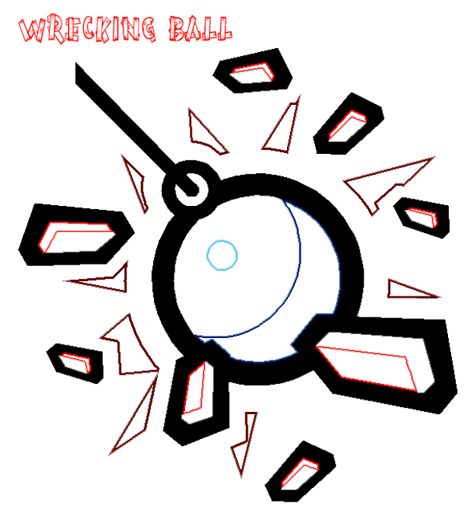

There are
Flying Debris

There are
Moving Vehicles

There is
Moving Equipment

Employee may
Strike Against
Something

There are
Sharp Edges

Employee may
Slip, Trip, or Fall

There are
Edges or Openings
in the Work Surfaces

There are
Pinch Points

(Employee may be Caught in or Between
or be crushed)
Employee may
Over-Exert

Task involves
Lifting, Twisting, or Carrying

Employee may come into contact
with
Something Hazardous

(Chemicals, Radiation, Dust, Fumes, Welding rays, etc.)
Employee may need to work in a
Hazardous Location

(Confined Spaces, Poorly Lit Areas, etc)
There is
Excessive Noise
in the Work Environment

Employee could experience
a sudden or unexpected
Release of Energy

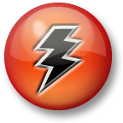

(Electrical, Heat, Pressurized Gas or Liquid, Mechanical Energy)
The employee has something that
May Get Caught
while doing the work


Flow of work may lead to overly
Rapid Movements

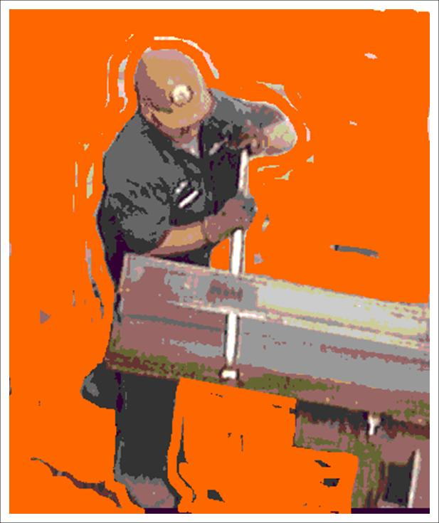
Work requires employee to perform
Repetitive Motions

There is
Poor Housekeeping,
clutter, or disorganization

Work requires use of
Personal Protection Equipment (PPE)

